
 | 
Funded by the Irish Government under  the National Development Plan 2000-2006   | EUROPEAN UNION  STRUCTURAL FUNDS  Part-financed by the European Union ERDF

Commercialisation Fund
2005

Commercialisation Fund
2006

Proposal Application Form

(Please read the General Details and Evaluation Process for the Commercialisation Fund 2006 -Technology Development before completing these forms)



Noise Controlled Semiconductor Optical Amplifiers

NCSOA



PRINCIPAL INVESTIGATOR: Dr. Pascal Landais

Commercialisation Fund - Technology Development

Notes on Completing the Proposal Submission Form

Administrative details F1 and F2
F1S and F2S should be completed by the Principal Investigator where the proposal is from a single institution.
F1C and F2C should be completed by the Principal Investigator and each collaborator should submit project details on form F2C where there is more than one institution involved.

Research areas
Use the following codes to indicate the area, within which the application should be considered,

1.0 Life Sciences / Biotechnology

2.0 Informatics

3.0 Industrial Technologies
The proposer may specify more than one area if appropriate, however they must be listed in decreasing order of relevance.

Eligible Costs
All reasonable additional direct costs involved in the implementation of the project are eligible for funding. However, the costs should be realistic and within the norms of the participating institution. A consideration of 'value for money' will generally apply and an unrealistic cost structure may damage the credibility of a proposal.
Unusually high costs may be allowed, provided that they are essential to the project and are properly justified in the proposal. At present there is no provision for the payment of institutional overhead costs and these should not be included. Funding for successful proposals will be based on the cost structure in the original application and with any changes made at the offer stage. This final cost structure will be fixed and cannot be changed without prior agreement by Enterprise Ireland.

Personnel
The categories of all staff to be involved with the project together with their time input and costs should be included. However, salary costs funded by other sources are ineligible for funding under this programme. The staff costs details including fees for postgraduates, annual salary increments, employers PRSI contributions and employer’s pension costs should be listed in section F3.3.1 ‘Justification of Costs’ of the proposal form.

Capital equipment and consumables costs
Details should be included of all items of equipment valued over €1,200. Only in exceptional circumstances will funding be provided for equipment that one would reasonably expect to be part of the infrastructure of the researcher's laboratory. An example would be where the intensive use of the equipment for the project is such that it that would not be available to others in the institution who would normally have access to it. Equipment costs should normally be less than 15% of the total project cost. Costs in excess of this require special justification.
Only consumables/materials that are exclusively required for the implementation of the project can be included as a cost. Excessively high consumables should be itemised and justified.
The total of consumables and capital should not exceed 30% of total cost without justification.

Travel
An outline should be included of relevant travel costs, for example travel to seminars/conferences, to specialist facilities elsewhere in Ireland or abroad where it is essential for the conduct of the project.

Commercialisation Fund
Technology Development Phase

For Office Use Only / /2006

Administrative Form F1C

(for use in the case of a collaborative proposal)
Project Title | Noise Controlled Semiconductor Optical Amplifiers
Acronym | NCSOA
Research Area(s) in order of relevance | 3
Co-ordinating Institution | School of Electronic Engineering  Research Institute for Networks and Communications Engineering (RINCE)
Department | School of Electronic Engineering
Address | Glasnevin, Dublin 9
Principal Investigator | Dr. Pascal Landais
E-mail | landaisp@eeng.dcu.ie
Tel | 7008044 |  |  | Fax: | 7005508
Has this proposal or a significant part of it been submitted for funding to another programme? NO
If so, please give details:
Signature of Principal Investigator |  |  |  |  |  | Date:
Signature of person authorised to endorse the participation of the Institution in the project |  |  |  |  |  | Date:
Name and Position in CAPITALS
Project Abstract (max. 100 words) This project deals with the realization of prototypes of low noise-figure (NF) semiconductor optical amplifiers (SOAs) with a high power saturation level. Their primary function will be in-line amplification in metropolitan and local networks, with markets expected to generate $7.5B in 2007. These devices are a major breakthrough in SOA technology, which can be designed, produced and characterized in Ireland. The reduced NF SOA performance can compete with any fiber amplifiers and present many advantages such as cost and integration. The feasibility of additional functionality such as wavelength conversion will also be investigated.

ADMINISTRATIVE FORM F1C

(For use in the case of collaborative projects)
SUMMARY SHEET
Start Date | 01/06/07 | Completion Date: | 31/05/10
Duration (Months) | 36
Collaborating Institution(s):
1 | School of Electronic Engineering (DCU)
2 | School of Physics (TCD)
3
4
5

Total Project Cost (Euro) Summary (of the individual details sheets)
Personnel by category: | Cost (€) | Person month
Lead Researcher (DCU) | - | 4
Lead Researcher (TCD) | - | 2
Post-doctoral Researcher | 170,667 | 36
Post-doctoral Researcher | 90,605 | 20
Post Graduate
Other
Sub-total pay: (a) | 261,272
Current non-pay
Consumables/materials | 32,000
Subcontract/consultancy | 40,000
Travel (domestic) | -
Travel (overseas) | 9,000
Other non-pay | -
Sub-total current non-pay (b) | 81,000
Total Capital: (itemise separately) (c) | 56,525
Total Project Cost (a+b+c) | 398,797

Capital Items
Item | Cost (€)
Optical Spectrum Analyzer (incl VAT) | 56,525

ADMINISTRATIVE FORM F2C
INDIVIDUAL DETAILS SHEETS FOR EACH INSTITUTION (CO-ORDINATERS AND COLLABORATORS)
A separate details sheet is required for each collaborating institution including the lead or co-ordinating institution
Name of Institution | Dublin City University
Role of Institution | Co-ordinating Institute
Department | School of Electronic engineering
Address | Glasnevin, Dublin 9
Contact Person | Dr. Pascal Landais
E-mail | landaisp@eeng.dcu.ie
Tel | 7008044 | Fax: | 7005508

Project Cost (Euro) applicable to this institution
Personnel by category: | Cost (€) | Person month
Lead Researcher | - | 4
Post-doctoral Researcher | 170,667 | 36
Post Graduate | -
Other | -
Sub-total pay: (a) | 170,667
Current non-pay
Consumables/materials | 28,000
Subcontract/consultancy | 40,000
Travel (domestic) | -
Travel (overseas) | 5,500
Other non-pay | -
Sub-total current non-pay (b) | 73,500
Capital (itemise separately) (c) | 56,525
Total collaborating Institution (a+b+c): | 300,692
Capital Items (add more rows as required)
Item | Cost (€)
Optical Spectrum Analyzer+VAT | 56,525

ADMINISTRATIVE FORM F2C
INDIVIDUAL DETAILS SHEETS FOR EACH INSTITUTION (CO-ORDINATERS AND COLLABORATORS)

Brief summary of the Institution's role in the project:
DCU will lead the project and co-ordinate all the aspects from growth, processing, design, characterization and commercialization.
A summary of their role includes:
Interaction with and selection of the most suitable growth and processing facilities.
Undertake the steady state characterization as well as coordinating the transfer of samples and characterization results with the collaborating institution.
Refine the simulation and design tools in line with material and processing parameters as well as the feedback form the experimental characterization.
Patent protect all IP relating to the novel SOA design and realization.
Initiate contact with relevant companies to determine the best route to commercialization.

Signature of Principal Investigator or Lead Researcher | Dr. Pascal Landais | Date:
Signature of person authorised to endorse the participation of the Institution in the project |  | Date:
Name and Position in CAPITALS

ADMINISTRATIVE FORM F2C
INDIVIDUAL DETAILS SHEETS FOR EACH INSTITUTION (CO-ORDINATERS AND COLLABORATORS)
A separate details sheet is required for each collaborating institution including the lead or co-ordinating institution
Name of Institution | Trinity College Dublin
Role of Institution | Collaborating Institute
Department | Physics
Address | School of Physics, Trinity College, Dublin 2.
Contact Person | Dr. Louise Bradley
E-mail | bradlel@tcd.ie
Tel | +353-1-8963595 | Fax: | +353-1-6711759

Project Cost (Euro) applicable to this institution
Personnel by category: | Cost (€) | Person month
Lead Researcher | - | 2
Post-doctoral Researcher | 90,605 | 20
Post Graduate | -
Other | -
Sub-total pay: (a) | 90,605
Current non-pay
Consumables/materials | 4,000
Subcontract/consultancy | -
Travel (domestic) | -
Travel (overseas) | 3,500
Other non-pay | -
Sub-total current non-pay (b) | 7,500
Capital (itemise separately) (c) | -
Total collaborating Institution (a+b+c): | 98,105
Capital Items (add more rows as required)
Item | Cost (€)

ADMINISTRATIVE FORM F2C
INDIVIDUAL DETAILS SHEETS FOR EACH INSTITUTION (CO-ORDINATERS AND COLLABORATORS)
Brief summary of the Institution's role in the project:

The collaborative institution, TCD, will characterize and assess the dynamic performances of the devices. The information extracted will be essential for determining the commercial potential of the novel devices and be fed-back to the simulation.
The following issues will be addressed:
Gain and saturation energy as a function of the injected pulse duration
Dynamics of the gain recovery
Characterization of pulse propagation
Polarization dependence of the gain characteristics
Investigations of cross gain modulation and four wave mixing wavelength conversion schemes

Signature of Principal Investigator or Lead Researcher |  | Date:
Signature of person authorised to endorse the participation of the Institution in the project |  | Date:
Name and Position in CAPITALS

PROJECT TECHNICAL DESCRIPTION

3: Project Description
The headings numbered F3.1 to F3.6 should be addressed using single spacing and a font size no less than 10. Guidance on the maximum number of pages (excluding appended charts, diagrams etc.) is outlined. Proposals should not exceed these limits.

F3.1 Objectives of the project (max. half page)
This section should give a clear, concise, unambiguous statement of the objectives of the project. It should convey to the reader, what precisely the proposer hopes to have achieved at the end of the project, if it is successful. It should not be a statement of why the work is necessary or of its scientific importance or of what the proposer intends to do. These are fully covered in the sections that follow.

This project deals with the development and the commercialization of cost-effective novel semiconductor optical amplifiers with enhanced performances.
The main objectives of this project are:
To develop prototype noise controlled semiconductor optical amplifiers (NCSOA) exhibiting a reduced noise figure and enhanced power saturation.
To determine the production cost of such devices by investigating performance reliability and device yield.
To assess the performances of NCSOA for future commercialization and refine the SOA design tools.
Steady state and dynamic characterizations for in-line amplification.
Investigate non-linear effects for potential wavelength conversion applications.
To secure the intellectual properties’ protection of the NCSOA.
To determine the appropriate route to commercialization for the NCSOA.
To engage with companies potentially interested in commercializing the product, with a view towards collaboration or partnership.

F3.2 Project summary (max. 2 pages)
The summary should be a self-contained description/overview of the project to be undertaken. It should be clear and concise for the scientific/technical reader and understandable to a scientifically literate lay reader.

The amplification function in optical networks is currently undertaken by erbium doped fibre amplifiers (EDFAs). This fibre technology offers a significant advantage over the competing conventional semiconductor optical amplifier namely the EDFA exhibits a lower noise figure performance. The EDFA also exhibits higher power consumption, it requires optical pumping, coupling optics, has a larger foot print, cannot be integrated on chip with other semiconductor technology and has a relatively narrowband of amplification. Alternatively the SOA offers lower power consumption; it is an electrically pumped device, has a small foot print, can be easily integrated on chip with other semiconductor technology and has a broad amplification range. Despite all these advantages over EDFAs the higher noise figure of the SOA significantly penalises its competitiveness. There is enormous commercial benefit to be achieved if a low noise figure SOA can be realised.

In this project, we propose to develop prototype noise controlled SOAs with a NF of the order of 6dB, competitive with current erbium doped fibre amplifier technology.

The initial study of the novel SOA concept has been undertaken theoretically as part of Enterprise Ireland project PC2005/0042. The novel concept is based around a slot pattern implemented along the active layers which clamps the carrier density along the amplifying waveguide. The theoretical results conclusively show that the novel design is a ground breaking advance in semiconductor optical amplifier technology, which would have enormous commercial impact. A draft patent was sent for independent external evaluation. The external expert assessment has found that two separate patents can be filed to cover the concepts behind the innovation, however it was recommended that experimental verification be undertaken to validate the claims and consolidate the intellectual property protection. The work undertaken as part of this proposal will provide the data and experimental verification to re-enforce the patent. This project proposes to develop prototype noise controlled SOAs (NCSOAs), which will demonstrate the technology and allow for a full assessment of its commercial potential.
The work is scheduled other three years and it involves two Irish research institutes. Two post-doctoral researchers will be hired for duration of 36 months and 20 months respectively.

The device growth and processing will be sub-contracted. We will work closely with these industrial partners to have accurate technological parameters for the simulation/design tool, for example material parameters, minimum slot width and separation, slot uniformity, doping levels and profiles etc. so that our simulation and design tools accurately reflect the devices produced. The software developed to date was created to demonstrate the possibility for a low noise figure SOA and has the capability to predict the noise-figure, the gain, the power saturation of SOA, carrier and photon densities along the structure. It is well adjusted and produces reliable results. Using this software we will be able to determine SOA designs with a reduced NF and high gain saturation power. The processing company will produce from the wafer devices according to our designs. A number of slot configurations will be implemented on the same wafer.

The first stage of characterization will require testing many NCSOA devices to select those which exhibit the best performance as well as comparing the performance from devices of different slot patterns. This study will also provide valuable information on the production yield and performance ranges. In steady state regime, with or without injection, we will measure the emission versus bias current, the gain, the saturation power, the noise-figure versus current and as a function of the wavelength of injected signal. We will characterise devices with a window in the negative contact, implemented using a focused ion beam. By measuring the spontaneous emission passing through the window we can probe the carrier density distribution. From these measurements, we will be able to relate the reduce value of the NF and the power saturation to the carrier density distribution and to compare this to our theoretical results. In parallel, the TCD group will carry out dynamic studies of the devices. We will study the gain and the chirp as a function of the pulse width. We will measure the performance of the devices in wavelength conversion schemes: cross gain and four-wave-mixing. From all of these dynamic measurements on this first iteration of devices, we will be able to extract further information on the parameters for the design tool and we will refine the model. We will also have experimental verification of the NCSOA concept. These data will be used to consolidate the patent(s) which will be finalised at this time. There will undoubtedly be additional claims in the final patent related to the fabrication and devices designs specific to 40 GHz and 160 GHz operation.
For the second iteration of devices, there will be designs with slot patterns for optimized noise figure and saturation energy performances at 40 GHz and 160 GHz bit rates. These devices will be tested in steady and dynamic regimes and compared to commercial SOA performances. Decisions on the feasibility and most appropriate route to commercialization will be taken at this time. The prototypes will be demonstrated to relevant commercial interests.

F3.3 Project Background, technical description and rationale (max. 4 pages)
The background to the project should be described, outlining why the proposed project is novel and innovative. The rationale for undertaking the project should be detailed, taking into consideration the current international state of the art, and the technical limitations of existing products, processes, methodologies etc. in the context of the objectives of the project. This section should include an assessment of the technical risks related to the deliverables and milestones in the work-plan and the contingency plans for dealing with them.

Project background
The most promising component to become the core of all-optical metropolitan networks is the Semiconductor Optical Amplifier (SOA). Besides acting as an amplifier, its inherent non-linearities allow it to be the basis of many signal processing functions (e.g. wavelength converters, logic gates). Compared to Erbium Doped fibre amplifier (EDFA), Erbium Doped waveguide amplifier (EDWA) or Raman amplifier, SOA has many advantages: lower cost, larger bandwidth, smaller size, potential to be integrated on a chip and electrical pumping. However it has one drawback, a higher noise-figure (NF) [1]. The NF is linked to excess noise introduced by the amplifier. It corresponds to the ratio between the signal-to-noise ratio at the input and at the output. It is essential to have this NF as low as possible.
Several approaches have been considered to solve this problem. One of them is on the SOA waveguide. It was showed that with a low confinement factor a reduction of the NF could be perceived. The results achieved are encouraging, but the NF of this device is still not as comparable to that of an EDFA [2]. Some laboratories have considered a chain of amplifiers, with a low NF SOA and low gain placed at the input and the noisier SOA with higher gain positioned further down in the amplification scheme. This approach should give some good results, however it does not solve the problem of a low NF SOA [3]. How can we achieve such device? Because in theory SOA could have a NF as small has 3dB. So far the results published are more in the range of 10 dB. Thus there is matter of improvement.
Another technique proposed at an early stage was to introduce of a control beam. In this set-up a powerful signal is injected in order to reach lasing condition. Consequently, the carrier is clamped; unfortunately this technique needs an extra beam. The results achieved are mediocre as most of the carriers are consumed by the injected signal and the signal to be amplified do not benefit from them. A solution is to embed a cavity inside the SOA [4]. These SOAs have the main advantage not to use an external signal. At a certain level of bias current, the SOA starts lasing, this results in clamping the density at a specific value corresponding to the gain equals the cavity losses. The cavity can be formed by (see for further details [5]):
- Two Bragg mirrors at both input and output of the SOA. This is a DBR-type gain clamped SOA.
- A single mirror distributed along the active layer. The mirror is placed in general along the n-side of the device. This is the DFB-type gain clamped SOA; Both of these designs are similar to that of an edge emitting laser.
- The metallic contact of the p-side, acting as a mirror and a Bragg mirror placed on the n-side side along the active layer. This design is similar to that of a VCSEL.
- or by DBR mirror placed on both side of the active layer and on the p-side as proposed in this project [7]. In our case, the cavity is lateral.

Project innovations:
Our design is possible by introducing mirror on both sides of the active layer parallel to the growth direction. The originality of our work is to use slots, manufactured imperfections to act as mirror. The advantages of this approach are:
- Low cost. As opposed to Bragg mirror requiring a regular change of low and high indices, which is costly from a growth point of view, the slots are produced at processing level by removing material. Therefore they are cheaper.
- The lateral cavity can be positioned along the gain section and it is not necessary to be evenly distributed along the active layer as demonstrated in [7]. This result is confidential and it has been published in order not to compromise the IP on the design.
- The sub-cavities can be designed to resonate at different wavelengths. This has an implication on the stability of the signal. It was demonstrated that the lasing mode should be on the short wavelength side of the gain peak to be sufficiently detuned from the injected signal. As the carrier transparency changes according to the local carrier density, the gain peak is red-shifted. With our design it is possible to tune the resonant wavelength always away from the gain peak.
- The mirror reflectivity is controlled, and this means that the carrier density can be clamped at different level of densities along the active layer, to minimize the NF.
- The sub-cavities are made of grooves etched along the p-side [8]. This technique is well developed in Ireland. Please see letter of support.

Technical description
The noise is reduced by engineering the carrier density along the active waveguide. Such a control is achieved using a distribution of the mirror reflectivity along the active layer, see Figs. 1 and 2.

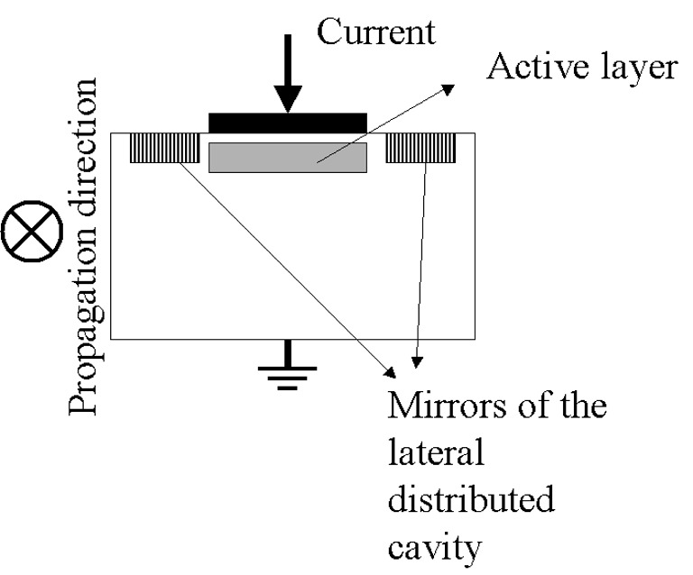 | 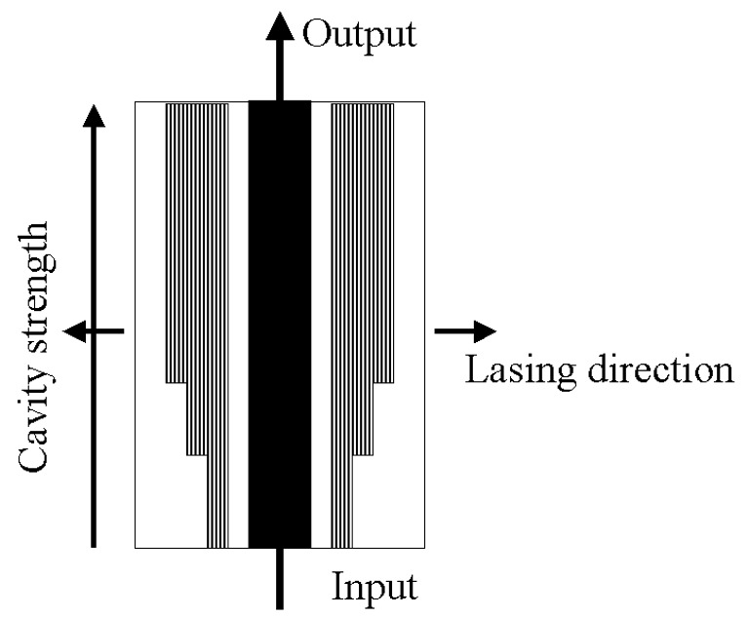
Fig.1: Front view of the NCSOA | Fig.2: Top view of NCSOA

The slots are placed on both sides of the active layer. The material removed from the semiconductor material changes the value of the refractive index underneath. Therefore there is spatial variation of the refractive index experienced by the field emitted. Constructive and destructive interferences are generated and a particular wavelength is selected. A cavity is established by the two mirrors embracing the active layer. The spontaneous emission coupled to the waveguide in the lateral direction will be trapped between the mirrors and amplified by the section of active material. Laterally the device acts as a laser, but longitudinally acts as amplifier. The carrier density contributes to the gain of the laser. When the current supply is as big as the threshold current, the carrier density is clamped at a density value where the gain provided by the semiconductor material equals the losses of the cavity.
Hence it is possible by controlling the level of reflectivity of the mirror and the resonant wavelength to set the carrier density to a given value.

Based on previous experimental and theoretical studies funded by RIF/2001/040, PC2004/331 and PC2005/0042 we developed a physical model to predict the NF. It is based on the integration of the rate equation. The device is divided into subsection for which the carrier density is constant. This simulation predicts the value of the carrier density, the gain, the noise figure, the photon density of the amplified signal and the spontaneous emission for each sub-section, and then for the full device. For instance the total noise figure is given by:
(1)
, where nf_{i} is the noise figure, g_{i} the gain of the i^{th} section and nf_{t} the total noise figure. This model has been tested by comparing its output with experimental results obtained in our laboratory or gathered in literature on conventional SOAs and vertically clamped SOAs (LOAs), third structure in the list above.
From some first simulations, it appears that the reflectivity of the mirror at the input of the device must be low. This is depicted by a smaller number of slots, in Fig.2 . This can be understood, if we consider again Eq. 1. To achieve a total noise figure as low as possible the first values of NF has to be as small as possible, this is reached if the carrier density of each of these sections is high.

We will have to optimise our model; this will be specifically addressed by interacting with the foundry and the processing company. We have found out the right mirror reflectivity and implementation along of the active layer to produce a reduction of the NF of >10% and an increase of the power saturation by >5dB. In this context the SOAs simulated have a NF close to that of the EDFA.

Risks and contingency plan
Optimized performance may require a slot pattern with specifications, in terms of accuracy and tolerance, beyond what is currently technologically achievable. However in this case patterns will be designed which are within the current processing limits and the optimum performance for the current processing technology will be determined. However this is not seen as a high risk as the early simulations indicate that the current processing technology is able to provide slot patterns such that the NCSOA will still exhibit a significantly reduced noise figure over current SOA technology. The drive to achieve better slot tolerances may lead to the development of further IP within the project.

References:
[1] J. Mork, M. Nielsen, T. Berg, “The Dynamics of Semiconductor Optical Amplifiers: Modeling and Applications” Optics and Photonics News, vol. 14, n 7, July, 2003, p 42-48.
[2] R. Brenot, F. Pommereau, O. Le Gouezigou, J. Landreau, F. Poingt, L. Le Gouezigou, B. Rousseau, F. Lelarge, F. Martin, G.H. Duan, “Experimental study of the impact of optical confinement on saturation effects in SOA”,
Conference on Optical Fiber Communication, Technical Digest Series, v 1, OFC/NFOEC 2005 Optical Fiber Communication Conference, Technical Digest, 2005, p 197-199.
[3] Patent number: US6731427 filled in 2004-05-04
[4] P. Doussiere, A. Jourdan, G. Soulage, P. Garabedian, C. Graver, T. Fillion, E. Derouin, and D. Leclerc, “Clamped gain travelling wave semiconductor optical amplifier for wavelength division multiplexing applications,” in Proc. Int. Semiconduct. Laser Conf., Sep. 1994, pp. 185–186.
[5] S. Verspurten, G.Morthier, R. Baets, “Experimental and numerical small-signal analysis of two types of gain-clamped semiconductor optical amplifiers” IEEE Journal of Quantum Electronics, vol. 42, Issue 3, 2006, pp:302 – 312.
[6] Patent number: US6,560,010 - 2003-05-03
[7] P.Landais, POC project PC/2005/042
[8] P. McEvoy, P. Landais, F. Logue, D. McDonald, J. O'Gorman, “ An optical waveguide and a method for providing an optical waveguide”, Patent number: WO0122543, Publication date: 29/03/2001.

F3.3.1 Justification of Costs (max. 2 pages)
All reasonable additional direct costs involved in the implementation of the project are eligible for funding. However, these costs should be realistic and within the norms of the participating institution. A consideration of 'value for money' will generally apply and an unrealistic cost structure may damage the credibility of a proposal.
Please list and include fees for postgraduates, annual salary increments, employers PRSI contributions and employer’s pension costs. Note: Employee’s recruitment, pension and redundancy costs are not eligible under this programme.
Please provide a brief justification of costs and explain the relevance of expenses to the project activities in terms of the specific work carried out (e.g. tasks, work packages, …)
Staff (€261,272)
Staff | Cost (€) | Person month
PI: Dr. Pascal Landais  10% (DCU) | 0 | 4
Lead researcher:  Dr. Louise Bradley  10% (TCD) | 0 | 2
Post-doctoral researcher:  Dr. Frederic Surre (DCU)  100%  Level 2, point from 3 to 5 | (Gross) 135,519  (PRSI 10.75%) 14,591  (Pension 15%) 20,357 | 36
Post-doctoral Researcher:  To be determined (TCD)  Level 2, point 3 to 4 | (Gross) 72,051  (PRSI 10.75%) 7,746  (Pension 15%) 10,808 | 20

The PI will spend 10% of his time on the project. He will be in charge of the writing- up of the patent occurring in Year 1 of the project.
The lead researcher of the School of Physics, TCD, will spend 10% of her time to supervise the progress on the dynamic characterisation of the NCSOA. Her involvement will be for a 20 month duration in this project.
Dr. Frederic Surre is the current researcher working on the Proof of Concept (PC/2005/0042). He has four year experience at a post-doctoral level. Based on his experience, he will start on point 3 at level 2 and will finish on point 5. He will be working full time on the project; he will be in charge of the co-ordination between DCU and TCD, the two external companies. He will carry out the research regarding the steady state study of the devices and the development of accurate simulation tools.

A post-doctoral researcher will also be based in TCD. He will be in charge of the dynamic characterisation of the novel devices. His activities will start at the end of Year 1 of the project for a duration of 20 months.
The simulation, device design and characterization experiments planned are quite sophisticated and an inexperienced post-graduate student would require significant time to master the techniques. Therefore post-doctoral researchers with suitable prior experience are most suitable. They will ensure that the research can be undertaken efficiently and with full attention to the commercial objectives of the project.
"Please note that it is normal Trinity College policy to request 20% pension contribution (in keeping with the Fixed Term Worker's Act) and the readjustment down to 15% has been done at Enterprise Ireland's request. However, this does not prejudice College's position that 20% pension should in fact be provided by the research sponsor."
'Social Benefits Clause: Fixed term contract workers have entitlements to benefits equivalent to full time permanent staff. Obligations arising from legislation associated with the employment of fixed term contract workers on the grant (including but not limited to pension provision, sick pay, redundancy pay, paid maternity leave or other paid or non-paid leave or entitlements) should be borne by the sponsor. Acceptance of the grant contract is predicated on the understanding that funding will be made available by the sponsor to cover such existing and any future pay costs that arise because of legislation and/or pay awards applied which are outside the control of the university.'

Consumable\Material (€32,000)
 | Year 1 | Year 2 | Year 3 | Total
Wafer growth (External I) | 12,000 | 12,000 |  | 24,000
Optical components (DCU) | 1,000 | 1,500 | 1,500 | 4,000
Optical components (TCD) | 1,000 | 1,500 | 1,500 | 4,000
The growth and processing of two wafers will be necessary for the development of the noise-controlled SOA. Workpackage 1 deals with the wafer growths scheduled at the beginning of both Year 1 and Year 2. Workpackages 2 and 5 include the wafer processing; they are scheduled respectively in the second quarter of Year 1 and last quarter of Year 2. The first wafer growth and processing are essential for comparison of the simulated and measured device performances. From the steady and dynamic studies we will be able to extract accurate material and processing parameters which will be incorporated in our simulation tools to achieve a high level of accuracy in the design. The second wafer and processing will be performed using the refined model designs and will produce optimized devices for comparison with current commercial technology.
Subcontract (€40,000)
 | Year 1 | Year 2 | Year 3 | Total
Processing (External II) | 20,000 | 20,000 |  | 40,000

Travel (9,000)
 | Year 1 | Year 2 | Year 3 | Total
Travel to CLEO US (DCU) | 2,000 |  |  | 2,000
Travel to CLEO EUR (TCD) | 1,500 |  |  | 1,500
Travel to ECOC (DCU) |  | 1,500 |  | 1,500
Travel to SPIE US (TCD) |  | 2,000 |  | 2,000
Travel to OFC (DCU) |  |  | 2,000 | 2,000
A researcher from each institution will attend a major conference each year, one in the US and the other in Europe. This will ensure that the team stay abreast of any rapid developments in the field, in competing or complementary technologies.

Capital/Equipment (€56,525)
 | Year 1 | Year 2 | Year 3 | Total
Optical Spectrum Analyser (DCU) incl. VAT | 56,525 |  |  | 56,525
Both laboratories in DCU and TCD are very well equipped to perform the experiments proposed in this project. However of the noise figure measurement in the steady state (work-packages 3 and 6) requires intensive use of an optical spectrum analyser, and unless one is purchased this facility will not be available to the project.

F3.3.2 Additional Project Background (max. 1 Page)
Additional material should be added where a researcher has received funding under an associated Enterprise Ireland programme for example Proof of Concept or Research Innovation Fund. The opportunity should be taken in this section to provide a summary of the results of this earlier work and its relationship to the proposed research programme. In particular the researcher should restate the objectives and the results obtained to date and develop the rationale for proceeding with the proposed research programme.

The project proposed has been initiated from the results achieved under the Enterprise Ireland proof of concept fund. The project entitled “Novel SOA device” (PC/2005/0042) was dealing with a theoretical study of the noise figure (NF) in semiconductor optical amplifier. The theoretical results achieved showed that it is possible to reduce the NF by controlling the carrier density distribution. Our simulation is based on the integration of a system of rate equation for infinitesimal sub-sections for the device under study. For each sub-section we assume that the carrier density is constant, but not systematically equal. The results of this system are the carrier density, the photon densities of the amplified signal and of the amplified spontaneous emission for each subsection, i.e. as a function of the position along the active layer. We are able to determine these densities under different conditions. From the carrier density and the photon density of the amplified signal we are able to calculate, the noise figure and the gain of each subsection. Using Eq.1 from paragraph F3.3 we are able to calculate the total noise figure of the SOA. In the case of a conventional SOA our theoretical results have been tested against the experimental results achieved in our laboratory and published in peer-review papers. We achieved a very good match between the simulation and the experimental results. The results are presented in Figure 1.

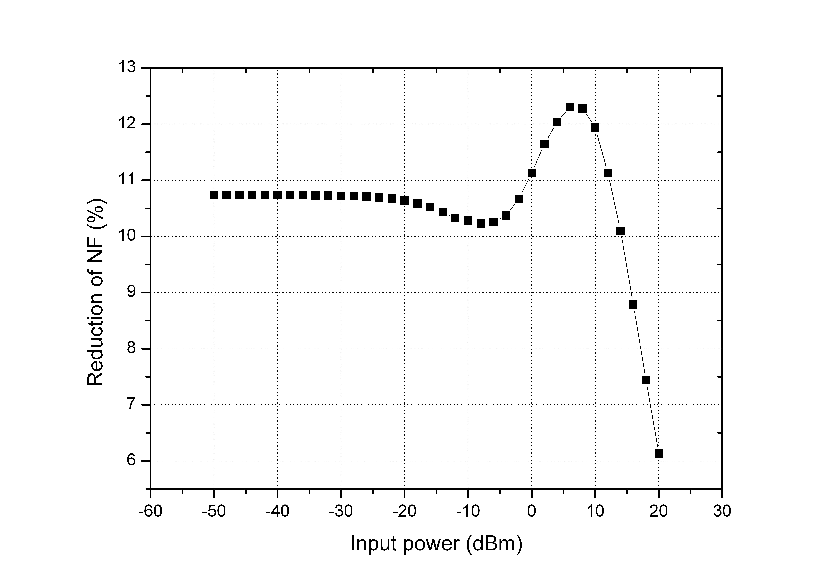
Fig.1: Reduction of the NF in NCSOA
as a function of injected power.

Without any particular care in optimising the NCSOA and using the same simulation parameters, it is shown that the NCSOA presents a reduction in the NF of >10% over a large range of injected power.

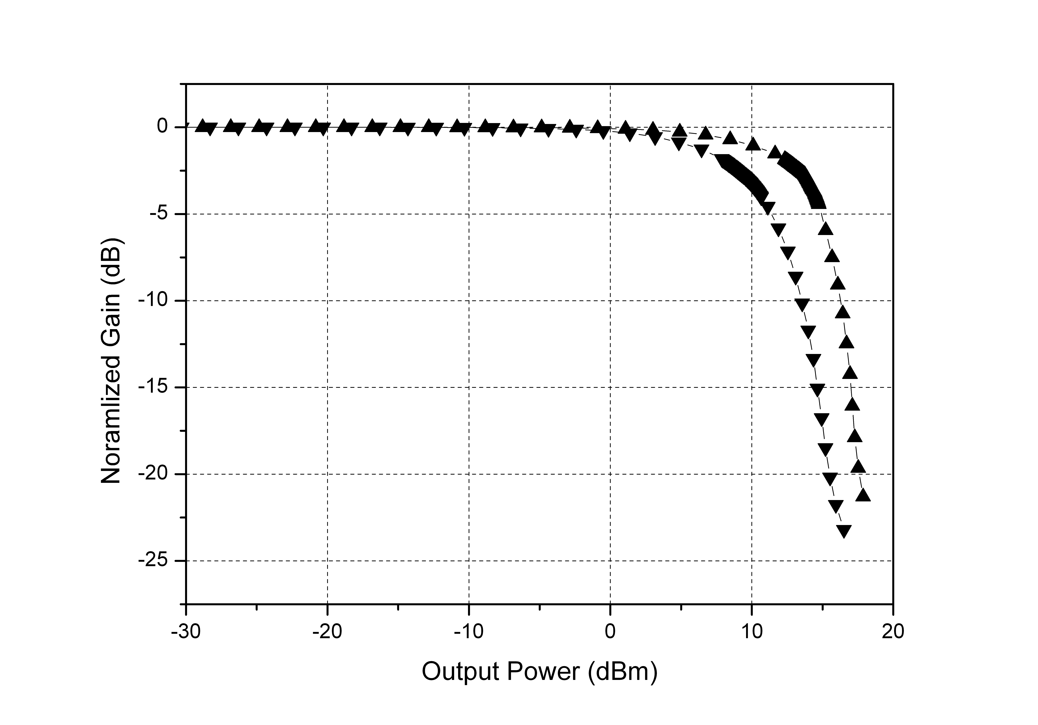
Fig.2: Normalised gain of the NCSOA (▲)
and a conventional SOA (▼) as a function of the output power.

Fig. 2 shows the normalised single-pass gain as a function of the output power for the NCSOA (▲) and a conventional SOA (▼). Both curves have been calculated using the same parameters. This figure show that the power saturation is 14dBm for the NCSOA and it is 9dBm for a conventional SOA.

In this proposal, we would like to look at controlling the carrier density distribution using lasing effect. The laser cavity will be achieved by implementing slots at key point along the active layer. This technique is well established in Ireland. It is worth noting that in the past, the DCU/TCD collaboration has been funded (RIF/2001/040 and PC/2004/331) to investigate the potential of nonlinear polarization phenomena in SOAs for optical switching applications. It was during these experimental and theoretical investigations that the concept of the NCSOA was first conceived. It was also during these earlier projects the dynamic test-bed in TCD was developed. This test-bed will be used in work-packages 4 and 7 of the proposal to characterise the dynamics on the NCSOA devices.

F3.4 Project plan and management
(max. 4 pages plus charts)
A concise description of the work-plan should be given. It should be broken down into work-packages, particularly in the case of collaborative projects, that reflect the logical phases of the project’s life. Each work-package should represent a significant and discrete part of the project and have clearly defined objectives and verifiable deliverables. The logical inter-relation between work-packages, scheduling and partner roles (in the case of collaborative projects) should be presented in diagrammatic form (e.g. GHANTT chart). Milestones should mark important decision points in the project. The costs associated with each work-package should be detailed.

The work proposed in this project is organized into 8 work-packages over a period of 3 years as shown in the Gantt chart attached. It is a direct continuation of the study initiated in the Enterprise Ireland funded PC 2005/0042. It consists of the development of a novel semiconductor optical amplifier with a controlled noise (NCSOA). We will undertake the device design and steady-state and dynamic characterizations with a view to assessing the technology. The growth and processing of two wafers will be subcontracted. The emphasis on the first growth run is experimental validation of the concept, test of the design tool, parameter extraction for refinement of the model and optimization of device performance. The second growth and processing run will produce prototype devices for 40 and 160 Gbit/s operations.

Work-package 1 deals with growth of the wafers. Growth of the first wafer will be initiated at the beginning of the project. A suitable grower will be sourced, for example IQE or the EPSERC facility in Sheffield, to grow a standard SOA wafer. As mentioned earlier there will be two growth runs; one scheduled at the beginning of Year 1 and the second at the beginning of Year 2. The growth runs constitute deliverables 1 and 2. The cost associated to this work-package corresponds to 2 wafer growth runs. The foundry is referenced in the Gantt chart as External I.

Work-package 2 is concerned with SOA design. Once the foundry has been sourced we will interact closely to update all material parameters in our model in line with the information from the growers. At this time we will also source a suitable processing facility and obtain the most up to date information from them on the slot tolerances, depths, widths and profiles. Using this information the first set of designs will be created incorporating a range of slot patterns to test the model, optimize the noise figure and the saturation energy/power. These device designs will be passed to the processing facility, referenced as External II, at the end of month 4. The realization of the first devices is deliverable 3.
The cost associated to this work-package is the personnel wages and the cost of one wafer processing.

Work-package 3 focuses on the steady state characterization of the devices. The first stage of this work is the testing of a wide range of devices from the processing run, in order to select the ones with optimum performances and to compare the performances of the different slot patterns to the theoretical predictions. Preliminary selection will be made on the basis of light output and low resistivity. For the selected devices we will measure the noise figure as a function of wavelength and bias current, the saturation power, the gain, gain spectrum. The second set of experiments will test directly for evidence of a clamped carrier density along the active layer. This involves studying the emission from the NCSOAs through a window on their n-side along the active layer, in order to evaluate the distribution of the carrier density and to evaluate the effect of the lateral cavity. The window can be implemented using a focused ion beam. These results will be analyzed and compared with simulation. This will allow for the simulation parameters to be refined and hence improved designs to be realized. This is Deliverable 4.
The selection of the devices and experimental verification of a reduced noise figure SOA is Milestone 1, and this data will be included in the patent.
The demonstatration of the reduction of NF and the improvement of the power saturation is Milestone 2.
The cost of this work-package is personnel wages, the purchase of an optical spectrum analyses needed for the noise figure measurement and some consumables for the experimental characterization test-bed.

Work-package 4 deals with the dynamic characterization of the devices. Devices selected as part of workpackage 3 will be studied. There are two parts to this workpackage, the first investigating the physical dynamic processes in the device and the second the potential for switching application. We will assess the gain dynamics in the pico-second and femto-second regimes in these novel structures. We will probe the dynamics of the carrier clamping and the gain compression as the pulse energy is increased. Parameters such as the timescales of the different components of the recovery will be feedback to the simulation. We also will measure the pulse distortion after propagation. In the time domain, we will look at any change in the pulse width and rise times and fall times. In the frequency domain we will look for any spectral components added to the original pulse spectrum. This information will assist in the development of the design model as we can access parameter such as the linewidth enhancement factor. We will look at the polarization dependence of the device. We have gained expertise in these measurement techniques through past projects. In Part 2 of this workpackage we will investigate the potential for system applications other than in-line amplification. The device will be investigated for wavelength conversion in cross gain modulation and in four-wave mixing schemes. From these measurements we will be able to assess the potential of the NCSOA for wavelength conversion, evaluate the maximum range of conversion and the optical signal-to-noise ratio of the converted signal. We will have devices designed for bit-rates of 40 and 160 Gbit/s. While we will not make any bit-error-rate measurement as part of this current proposal, the measurements we have selected will evaluate the performance of the device with 8-ps and 2-ps pulse-width signal propagating through the device. On the other hand, the analysis of the experimental data will lead to further understanding of the dynamic of this type of SOA. We will be able to extract linewidth enhancement associated to carrier-heating and spectral-hole-burning. The parameters and dynamic behavior will be used in the design model. The completion of the dynamic characterization is Deliverable 5.
The only costs are personnel and consumables of the experimental characterization.

Work-package 5 There are 2 distinct parts to this workpackage. The first is simulation of the experiments undertaken in work-packages 3 and 4, while the second is the optimization of the NCSOA design. The comparison between the numerical results and the experimental results will allow a full understanding of the physical mechanisms dominating the observed behaviour to be developed. It will also allow for parameters to be estimated/quantified, which will be fed-back into the device design tool. New designs will be achieved and transmitted to the processing company. This design iteration will also take into account the feedback from the commercial partners, see workpackage 8. Final set of designs constitute Deliverable 6. The realization of the second batch of devices is Deliverable 7.
The cost of this work-package is personnel and devices processing.

Work-package 6 The second batch of devices will be characterized using the same techniques as in Work-package 3. This will involve the selection of the key devices to be tested, the comparison of the different designs implemented and confirmation of the optimum noise figure that can be obtained. The performances in steady state will be compared to that of the simulation. We will be able to determine the ideal working conditions leading to the best performance in term of gain, power saturation and noise figure. Finally this data will be compared with the state-of-the-art in amplifier technology. This is Deliverable 8.
The only costs are personnel, consumables for the experimental characterization.

Work-package 7 The dynamic performances of selected devices form the second batch will be undertaken. We will focus on selected experiments, based on the knowledge developed in work-package 4 From this work we will assess the NCSOA performance as in-line amplifier and for all-optical wavelength conversion. The dynamic results form Deliverable 9. At the end of this work-package we will compare the NCSOA performances to those of conventional SOA. This is Milestone 3. The primary output of this project is an optimized low noise figure SOA for in-line amplification applications, competitive with EDFA performance. Hence we will be able to assess the commercial potential of this new type of SOAs. From the dynamic studies we will also have investigated the potential for use of this novel device for switching applications such as wavelength conversion. Advantages and disadvantages relative to conventional SOA switching capabilities will be determined, Deliverable 10.
The only costs are personnel, consumables for the experimental characterization.

Work-package 8 deals with the commercialization of the device.
The first part of this workpackage is concerned with consolidating and re-enforcing the patent. The relevant design, simulation and experimental verification will be added to the patent at the beginning of Year 2. This will form milestone 3. During the entire project careful attention will be paid to the development of further IP which may arise for device designs, development of specific processing techniques or the potential of these devices for switching applications, for example wavelength conversion which will be investigated. Once the experimental evidence has been demonstrated and the patent finalized we will make contact with potential indigenous industrial partners. We will assess their market needs and their suitability to bring this technology to commercialization. However we will also consider the possibility of licensing the technology to an international component/network manufacturers if there is not a suitable outlet in the indigenous market. There is also the possibility for a high potential start-up company, which would be spun-off from DCU. A decision on the route to commercialization for the NCSOA will be taken at the end of the project and constitutes Milestone 5. The only cost associated with this workpackage is salary.

Management
The project will be co-ordinated by PI. In the first year the main activities are based on design and device selection, to be undertaken in DCU. From year 2 TCD will undertake dynamic characterization of the devices. The lead researchers in each institution will have weekly meetings with the post-doc working under their supervision. There will be a monthly meeting with the DCU PI, the TCD lead researcher, Dr. Bradley, and the two-postdocs to direct the research, monitor progress and assess the commercial aspects of the results. These meetings will also to ensure efficient transfer of devices, experimental results, simulation results and feedback of parameters for the design tool. The close proximity of the two institutions will allow for regular contact between the researchers working on the project even more frequently if required. The DCU PI will co-ordinate all the aspects from growth, processing, patent filing and initiation of contact with industrial partners.

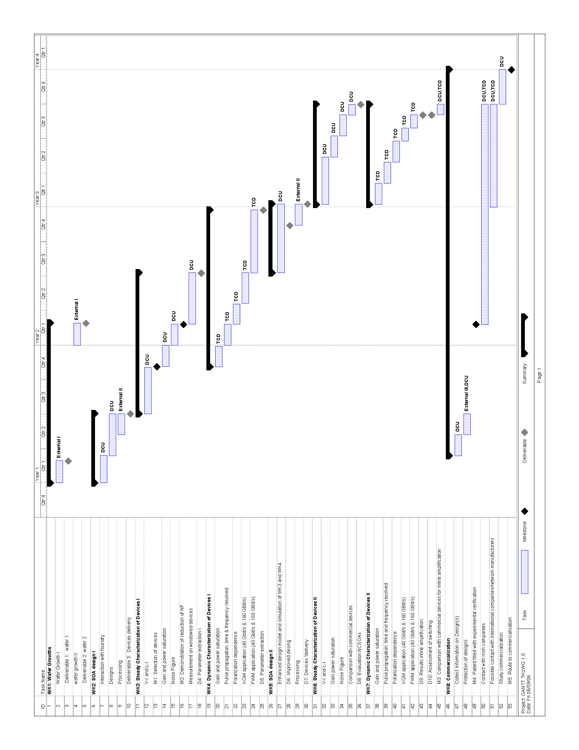

F3.5 Track record (max. 1 page)
Curriculum Vitae –Pascal Landais: PhD, MIEEE, Marie-Curie Fellow.
Current position: Lecturing and research in the domain of optical communications, DCU, since Jan. 2001
Previous appointments
R&D, strategy development and management, CeramOptic, Ireland, from Sep. 1999 to Dec. 2000
Management & co-ordination of research projects, Optronics Ireland, from Mar. 1996 to Sep. 1999
Research on high speed semiconductor laser, France Telecom, from Oct. 1992 to Dec. 1995
Patents and Exploitation:
P. Landais,” A self-pulsating laser and method of production thereof.” Patent number: 2005/0251.
P. McEvoy, P. Landais, S.A. Lynch, J. O'Gorman, Patent number: WO0178205, currently licensed to EblanaPhotonics Ltd.
P. McEvoy, P. Landais, F. Logue, D. McDonald, J. O'Gorman, Patent number: WO0122543, currently licensed to EblanaPhotonics Ltd.
Publications
6 papers in IEEE J. Quantum Electron, 2 IEE Proc.-Optoelectron., 2 IEEE Photon. Technol. Lett., 2 IEE Electronics Lett.,1 Applied Physics Lett., 3 invited presentations, 37 Oral or poster presentations.

Curriculum Vitae – Dr. Louise Bradley : C. Phys.
Current position:
2001- present: Lecturer, School of Physics, Trinity College Dublin
Previous appointments
Oct. 1999 – Jan. 2001: Lecturer, Institute if Technology, Tallaght, Dublin
Oct. 1998 – Oct. 1999: Post-doctoral research fellow, Trinity College Dublin
Research Activities
Principal investigator: supervising 4 post-graduate students and 2 post-doctoral researchers
Author or co-author of over 50 publications and over 40 international conference presentations
Co-author of 2 filed patents
Drawn down research funding (> 1.4 M€) via open competition from national agencies
Current formal and informal collaborations within Trinity Physics and Chemistry departments and with other research institutions: Dublin City University, INSA Rennes, University of Hamburg, Germany and CICESE Mexico.
Professional activities
Frequent referee Journal of Quantum Electronics, Photonics Technology letters, Applied Physics Letters, Journal of Lightwave Technology
Advisory committee member for PLMCN 2004
Panel member Semiconductor Photonics section Opto-Ireland, April 2005.
Project evaluator for national and international agencies
Examiner for MSc and PhD theses

F3.6 Commercial potential and economic importance
It is the responsibility of the proposer to describe in a convincing way the perceived commercial potential of the project output in the context of the stated objectives of the programme (to generate technologies, products or processes which provide the basis of new business areas in Ireland or which improve the competitiveness of industry in Ireland). The detail in terms of the economic relevance of technology provided should reflect the stage of development of the technology and as such where it is close to market a greater degree of detail will be expected.
Where relevant, a developmental phase may be included describing the next stage in commercialising the output of the project. However, it is not a requirement that the researchers themselves should have plans to personally undertake or even be a part of the commercialisation. Commercialisation of projects with demonstrable potential will be undertaken in the most appropriate way following consultations between Enterprise Ireland, the institution and the researchers.

Semiconductor optical amplifiers (SOAs) have a very promising future in both arenas of in-line amplification in metropolitan networks and all-optical data processing. The market of all-optical processing is too difficult to estimate as the technology is still undergoing R&D. However, before the telecommunication crash of 2002, the in-line market size was estimated at $7B for 2004 [1]. Now, the indications seem to show a recovery of this market, mostly driven by the metropolitan network. Prospective studies on the Metro Ethernet system indicate a $7.5B market by 2007. This figure embraces the overall system; we guess that about 3% will contribute to the SOA market. Therefore, the low noise-figure SOA device, we would like to produce in this project will target a market of at least $225M. This figure does not include the market share that this device can gain over the competitors, and the potential market the optical data processing.
In a previous Proof of Concept (PC/2005/0042) a theoretical model has been developed to simulate the noise figure of any SOA design. With this tool, we were able to achieve an SOA design resulting with a dramatic reduction of the NF without impairment of the power saturation. A process has been established with IBR of DCU. The innovation has been submitted to external adviser in order to proof test the innovation proposed. In his opinion there is IP to be protected and validated. The innovations proposed in the design are original and achievable. In order to strengthen the patent a prototype needs to be developed, which will be undertaken as part of this proposal. We have already sourced tow potential sub-contractors to undertake the processing of our novel structures. A decision on which option is best will be taken after consultation on the requirements of the novel designs and the achievable slot pattern parameters.
[1] http://www.gii.co.jp/english/su6515_optical_amplifiers.html
[2] http://www.infonetics.com/resources/purple.shtml?nr.met.011904.shtml

F3.6.1 Technology Description (max. 1 page)
Describe the project in terms that a “layperson” can understand. Include a technology description that is suitable for review by individuals with a business background. The commercial evaluator will wish to know what the product or process does rather than how it works. What similar products or processes are in the market and what are the potential advantages of your product/ process over the competition?
The light injected in semiconductor optical amplifiers (SOAs) is amplified by stimulated emission. They benefit from many advantages as an amplifier: a large amplification about 30dB; a reduce polarization sensitivity, less than 2dB; an amplification bandwidth from 1200 and 1700 nm. For instance in a 40x10⁹ bit/s wavelength division multiplexing network, the channel spacing is 100GHz. This means that 125 channels can be launched and amplified in one single SOA simultaneously. The other consequence of this extended gain bandwidth is that SOAs are able to amplify signal out side the C and L bands (1528-1562nm and 1625-1675 nm). This is not the case for three of the main competitors, Erbium Doped Fibre Amplifier (EDFA), Erbium Doped Waveguide Amplifier (EDWA) and Raman amplifier confined to these bands. SOAs are cheap to produce; they are Fabry-Perot based devices with anti-reflection coatings. They are electrically pumped; this is a real advantage over EDFA, EDWA or Raman amplification requiring optical pumping. This implies that no extra optical sources are needed to pump the doping and then amplify the signal, no power supply for the optical source, and no lens, coupler and mechanical apparatus to position the pump laser and to launch the pump signal. Consequently the foot print of any SOAs is reduced and their running and production cost too. The only disadvantage of the conventional SOAs with respect to their competitors is a too high noise figure (NF). The noise figure quantifies the excess noise introduced by the optical amplifier. The smaller is NF the better it is. In this project, we proposed to produce a prototype based on the results of our previous study. The potential of patents on this innovative type of SOA has been assessed and it is clear that the novel SOA is a leap forward in the SOA technology. We predict a reduction of NF in these devices by at least 10% and an increase of the gain saturation of >20dB, in this case the SOA developed will have a NF parameter equal to that of the EDFA. Thus, with their advantages already mentioned they will compete directly with the fiber amplifiers. In order to copper fasten our patent application we would like to produce a prototype. We have been in contact with an Irish-based company, Eblanaphotonics, who are very interested in the potential of this technology, see letter of support. They have offered to provide, on a commercial basis, their processing expertise to assist with the realization of the prototype devices, as mentioned previously a decision on an appropriate processing sub-contractor will be taken once the first iteration of designs have been finalized and the slot parameter tolerances required have been established through simulation.
F 3.6.2 Target Market and Competition (max. 2 pages)
- A description of the target application.
The goal of this project is to produce a cost effective semiconductor optical amplifier with a reduced noise figure. The target applications of these devices are multiple: 1) Current metropolitan network will be the first main consumer. The novel SOA will be used as in line optical amplifiers; 2) Next generation of optical network is the second key consumers. The fact that our novel SOAs will provide amplification with minimised degradation of the optical signal-to-noise ratio, means less SOAs will required along the network. Devices optimised for 40 and 160 Gbit/s operation will also be realised and will suitable for netx generation applications. 3) SOAs are non-linear devices, and consequently they can be used to performed all-optical functions. With a reduced NF, these novel SOAs will be exploited in the all-optical data processing systems.
- What you perceive the market requirement to be. This information should be available in trade magazines and the web.
The market needs a low cost, low noise figure, small foot print, low power consumption, easily integrated, broad gain optical amplifier operating at 40 and 160 Gbit/s. Since the burst of the telecommunication bubble the driving force of the optical communication industry is low-cost solutions. This results from the fact that the market is not driven by performance but by the introduction of new services. Broadband is more or less accessible worldwide [1]. The optical back bone of the network has been over-built and added to the fact that the silicate fibre transmission window is 23 THz wide, considering the C and L bands, the common feeling is that the bandwidth is infinite, “up for grabs”. However, recent studies on the internet data transfer indicate a growth of 115% per year, this does not take into account the need of emerging economies. It is predicted that in less than 5 years the transatlantic capacity will be saturated. The US have increased by 20% the growth of fibre installed, but this deployment will not be enough [2]. The current telecommunication technology as we know it has reached some technological limits. Some research are carried out towards an all-optical telecommunication networks in order to remove the electronic bottle-neck; a global solution with pan-continental, metropolitan and local optical networks keeping the information in an optical format. The Europe is also pushing to bring the fibre at home [3]. Our NCSOA will compete in this low cost environment. It will have lower production costs, lower running costs, a competitive noise figure and higher bandwidth.
- Identify what is driving the market (cures for heart disease in the medical sector, cost reduction, increased speed of devices, etc.).
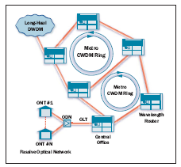
The driving force is the deployment of FTTx (Fibre To The x. x stands for Premises, Home, Curb, Building, Node or Office ) and xPON (x Passive optical Network) broad band access. The cost of bringing high capacity fibres to residential users is steadily decreasing. The technology used for the network in this context, must be low-cost in order to make the local network feasible. There are different designs for networks emerging. For example wavelength division multiplexing but this network option requires very expensive technology due to the very small, <1 nm, channel spacing. An alternative is the coarse WDM (CWDM) network. It provides solutions at a bit rate of 10 or 40 Gb/s for a working wavelength of 850, 1300 or 1500nm. It treats up to 15 channels spaced 20nm. Fig.1 illustrates a CWDM interface with a PON. Such a network has already been approved by the ITU-T. The CWDM-based FTTP exploits the PON technology to carry the optical signals to the end user. One of the key components in the network is the amplifier, amplifying the signal to the level required by the detection system. As detailed earlier, the NCSOAs offers such a low-cost solution, with competitive and in some cases, such as bandwidth, higher performances, as well as the potential for additional functionality through exploitation of non-linear behaviour. They can be used for amplification between 1200 and 1700 nm and they enable new applications in optical data processing due to its fast recovery time. The bandwidth limited EDFAs are not an option over this range. The novel NCSOA also competes well against the conventional SOA for these applications as the lower noise figure means fewer amplifiers are necessary as the OSNR is less degraded by the amplification scheme.
- Who are the key players in the market – include actual company names.
The key players in metro network manufacturing are Alcatel, CISCO, and Huawei. According to Infonetics, worldwide metro Ethernet equipment revenue hit $2.9 billion in 2003, and is projected to grow over 150% to $7.5 billion by 2007 [5]. It is fair to assume that about 3% of this amount is actually used for SOAs.
These manufacturers supply clients such as Los Angeles Department of Water and Power, AT&T; in Europe: Telefonica, BT; and in Asia, Japan Telecom, China Telecom, Gas Authority of India Ltd [1]. This list demonstrates the level of activity in the optical network market, with many organizations exploiting their existing infrastructure and networks (e.g. waterways, trains, electric grid) to diversify into the optical network arena.
SOAs are supplied to the metro network manufacturers by Avanex, CIP, Kailight, Fujitsu, Genoa, NTT Electronics Corporation and Sumitomo.
- Who are the competitors and what are the competitive technologies?
As mentioned before the competing technologies are EDFA, EDWA and Raman amplification. The EDFA market is dominated by Thales, Alcatel, BaySpec or Fujikura. The EDWA is still under research and development; however we can mention a Danish company NKT integration. Regarding the Raman amplification one of the key companies is MCI.
- What way is the new technology expected to be better than the existing technology, will it be faster, cheaper, etc?
The technology proposed is better because it addressed the only drawback that was limiting the integration of the SOA in metro networks. With a noise figure equal to that of the most popular amplifier, the EDFA the novel SOA will be attractive, since it offers many other advantages, such as higher bandwidth, lower power consumption, smaller foot print, opportunities for on-chip integrated devices as outlined previously. A key point is that our NCSOA is a low-cost solution. We can quantify the advantage by comparing the purchasing cost of an EDFA and a conventional SOA. An EDFA costs in the region of €20,000 (Thorlabs), depending on the specification, whereas an SOA costs in the region of €4000.
- How does it overcome the limitations of existing technology?
The novel SOA devices will have a reduced NF by introducing an extra control on the origin of the noise, through the implementation of a lateral cavity where the mirrors are formed by slots in the semiconductor material, as detailed in the technical part. From a manufacturing point of view, the extra cost in producing the device is very small (<10%) , as it can be incorporated directly as part of the processing. The additional cost is specifically associated with a more complicated mask and the need of one etching process. The overall cost of the NCSOA will still remain significantly below the production costs, purchase price and running cost of an EDFA.
- Are there known barriers to market acceptance, e.g., regulatory, acceptance testing, standards compliance, patenting, etc?
By using the novel SOA, the metro network manufacturer have lower cost base and will increase the capacity of their network, as SOAs have a wider bandwidth. Further more the deployment of SOAs in the networks allows the possibility for all-optical data processing. By introducing these devices in their networks, network manufacturers can anticipate new functions and prepare their product for the next generation of optical communications. Once the novel device performance has been demonstrated the only barrier to market penetration is the inertia in the adoption of a new technology, but the advantages listed above make our NCSOA a highly attractive and cost effective option.

[1] www.telegeography.com
[2] www.kmipennet.com
[3]http://europa.eu.int/information_society/eeurope/2002/news_library/documents/eeurope2005/eeurope2005_en.pdf
[4] ITU-T Recommendation G.656: characteristics of a fibre and cable with non-zero dispersion for wideband optical transport.

[5] http://www.infonetics.com/resources/purple.shtml?nr.met.011904.shtml

F 3.6.3 Project team (max. 1 page)
Identify key members of the team. (PI, Senior Researcher, etc.)
- What strengths do the team members bring with them? Product commercialisation experience, technology management experience, technology expertise, business skills, patenting?
- Identify experience and track record in product commercialisation, successful licensing deals, commercial sub-contract work including participation on Innovation Partnerships, etc.

Dr. Pascal Landais of the Radio and Optical Communications Laboratory within the Research Institute of Networks and Communications Engineering, DCU is the PI for the project and has a strong track record in the invention of commercial intellectual property in the semiconductor optical device arena. Two of his world-wide patents are currently licensed to Eblanaphotonics. He was also the Research and Development manager in CeramOptec Ireland from 1999 to 2001. The details of his research during this time are subject to confidentiality agreements but the hand held laser developed has been commercialized and is available worldwide. Dr. Landais is aware of the industry needs and on other topics he collaborates closely with the III-V lab associated with one of the largest optical network companies in the world Alcatel/Lucent. Dr. Landais is the unique author of a patent filed in 2005, “A self-pulsating laser and method to generate short light pulses”, No 2005/0251 and a fourth patent detailing the novel SOA structure outlined in this proposal has received excellent feedback for the eternal assessor. The second member of the DCU team is Senior Researcher Dr. Frederic Surre. He has been working on SOA simulation and characterization with Dr. Landais over the past two years and has played an important role in the implementation of the simulations to test the concept behind the novel technology which will be further developed in this project. Dr. Surre’s participation will ensure efficient and accurate design computational tools are implemented.
Dr. Louise Bradley is based in the School of Physcis of Trinity College Dublin. She currently leads a team of 4 post-grads and 2 post-doctoral researchers. She has an expertise in fast phenomenon in semiconductor material. She has over 50 publications on the optical properties of semiconductor materials and device applications. Since joining TCD in 2001 Dr. Bradley has been a lead researcher on the development of microcavity enhanced two-photon absorption based photodetectors for optical network applications. She is co-author of two patents protecting the IP invented as part of this work. She has lead projects investigating the dynamics of nonlinear phenomena in semiconductor optical amplifiers, undertaken in collaboration with DCU. This novel work is currently submitted for publication and has been the subject of invited presentations, most recently at ICTON 2006. Dr. Bradley has developed a state-of—the-art test bed for semiconductor optical amplifiers dynamic studies in the picosecond and femtosecond regimes. She can investigate pulse propagation and the dynamics of the carrier distribution and gain saturation. Furthermore the system has been fully implemented in a free space configuration which provides full control of the polarization the injected signals.

F 3.6.4 Route to Market (max. 1 page)
What partnerships are planned throughout the life of the project? Suggestions include: Informal interactions with potential end users of the technology early in the project will provide benefits, e.g. market information, product specifications etc.
Licensing the product or technology. Potential licensees can provide solid market and technical information particularly about the competition and future market requirements.
Early exposure to the VC community and other funding sources may be beneficial in terms of steering

The patenting process of the innovative SOA is well advanced already. A first assessment on the originality has been performed with an external consultant under non-disclosure agreement. Two intellectual properties have arise from our SOA designs and our first objective will be to protect these IPs. The 3 most likely routes to commercialisation are:
1. Licence the technology to an Irish based company, and subsequently continue to work closely with them in the development and testing of a final product in an industrial partnership. Funding for such work could be applied for through EI industrial collaboration schemes, such as the innovation partnerships programme. This interaction could begin immediately, once a full characterisation of the devices is completed. (No companies have yet been approached as this is felt to be premature given the stage of the patent protection and lack of experimental support.) Ultimately, this option is also the most suitable for Ireland Inc. as it promotes indigenous development and employment opportunities. Photonics is an important part of the innovation culture in Ireland as is evidenced by the number of spin-off photonics based companies (for example EblanaPhotonics, Intune Technologies, PXIT, EMC or Firecomms) within the past decade. The technology proposed matches the expertise and commercial capabilities of many of these companies and consequently there is real potential, that if successful, this novel device can be commercialised in an indigenous company. These companies will have to continue to develop their range of products if they are to remain competitive in the future. Photonics is a global industry and, if proven successful, the innovative device will have to be brought to a global market. The indigenous based photonics companies have demonstrated their capability to compete on a global stage. Furthermore, the development of new and innovative products will further enhance the position of Ireland on the global stage.
2. Licence the technology directly to an international manufacturer. It is important to note that our patent strengthened by the experimental work carried out in this project will protect the SOA design. This option will result in substantial IPR royalties, and while it may not directly lead to indigenous development and employment, it would raise the profile of the research and development capabilities in Ireland and undoubtedly lead to other opportunities.
3. High potential start-up company. This option will only be considered after the possibilities for licensing have been fully investigated. It would require a much longer lead in time before the product would be in the market place, and is the least attractive of the three options. The start-up company may be either a new business or a joint venture between an existing company and the research institute.
All possible commercialisation routes will be fully explored in conjunction with the IRB in DCU and Enterprise Ireland.

F 3.6.5 Patent Protection and software copyright
(max. 1 page)
Are there any obstacles to patenting? Any patents owned by third parties, which may inhibit commercialisation?
Is there a clear distinction between background IP and the foreground IP proposed in the project?
Note: A declaration, on behalf of the Designated Institution, pertaining to ownership of Foreground IP, must be signed if the proposal is successful and a contract is awarded.

All IP relating to the NCSOA has been developed by the PI and F. Surre. There are no issues inhibiting commercialization.

A research has been carried out on the website Espacenet. One patent relevant to our invention was found, Patent [1]. It is interested in gain clamped semiconductor optical amplifiers and their performance when coupled in series or parallel. This patent does not deal with a device as presented in our project. Our method to achieve gain clamping is different to that in Patent [1] 1) In their case a vertical cavity is formed between the top contact and a mirror embedded in the n-doped section of the SOA, in our case the cavity is formed laterally by two Bragg mirror; 2) The resonator is a Fabry-Perot, multimode, in our case there is only one mode lasing; 3) They cannot select the lasing wavelengths whereas we can and this lead to a better stability, 4) Their mirrors are placed other the entire length of the SOA, whereas we can select the position and length of the lateral cavity.

Paper [2] deals with the crosstalk in mutielectrode SOA. The authors showed that a non-uniform current lead to a reduced level of crosstalk. Their work is not concerned with optimum current distribution or the noise figure. The implementation is done by means of a varying bandgap material.
Our SOA design is fundamentally different in both implementation and performance.

References:
[1] Patent number: US6,560,010 - 2003-05-03
[2] J.Lin et al, IEEE Phot. Tech. Letters, 16, Feb. 2004, pp.392-394

F 3.6.6 Milestones (max. 1 page)
The Commercialisation Plan should include a Commercialisation Roadmap. The Roadmap should be kept simple but could contain plans for meeting with potential licensees to investigate commercial plans, first demonstrations of technology, revised specifications and further demonstrations, etc. Plans for reviewing and updating the Roadmap throughout the project should be included.
on PC formatted diskette or CD. At least one copy of the submission should be bound as an archive copy. Other copies may be stapled.

There are four milestones identified, as in the work-plan.
Milestone 1 is the experimental selection of devices.
Milestone 2 is the demonstration of a reduced noise figure SOA.
Milestone 3 is the assessment of the commercial potential of the NCSOA for in-line amplification applications.
Milestone 4 is the consolidation and re-enforcement of the patent by inclusion of the additional design, characterization and processing information.
Milestone 5 is the decision on the appropriate route to commercialization for the device, to e taken at the end of the project.

Workpackage 8 is dedicated to the commercialization of the NCSOA.
During the entire project careful attention will be paid to the development of further IP which may arise for device designs, development of specific processing techniques or the potential of these devices for switching applications, for example wavelength conversion which will be investigated. Once the experimental evidence has been demonstrated and the patent re-enforced we will make contact with potential indigenous industrial partners and demonstrate the technology developed to date. This technology could be of interest to a number of photonics companies based in Ireland, for example Eblanaphotonics, Intune Technologies, PXIT, EMC and Firecomms to name some. It should already be noted that Eblanaphotonics have expressed interest and have provided a letter of support. The technology will be firstly introduced to the indigenous companies in the first quarter of Year 2. We will assess their market needs and their suitability to bring this technology to commercialization. We will also be attending major conferences during the project to stay abreast of any developments in the amplifier field. The second iterations of designs will focus on the key amplifier performance requirements for the operating regimes determined to be of most interest to the industry as identified through discussion with potential industrial partners and the developments in the competing market technologies. We will and have already identified international companies who may also be interested in this technology, for example Avanex. If there is no suitable indigenous licensing partner the international market will also be investigated. This will be initiated during year 3. The proposers have not ruled out the option of a HPSU, which would be spun-off from DCU. and a clear picture of the most appropriate option will undoubtedly emerge from the discussions with industry. The final decision on the route to commercialization will be taken at the end of year 3.

Time commitments of all those associated with the project should be shown, even where they are not charged to the project.
Time commitments of all those associated with the project should be shown, even where they are not charged to the project.
Time commitments of all those associated with the project should be shown, even where they are not charged to the project.

