The main purpose of this proposal is to explore the potential of InP-based InAs quantum(Q)-dots self-pulsating Bragg reflector lasers as a local oscillator for all-optical re-amplification, re-timing, and re-shaping (O3R) function.
A full theoretical and experimental study of an optical clock recovery based on this novel self-pulsating laser will be carried out. This implies the design and the realization of devices, their characterization and assessment of their performances as clock recovery function in a 40 Gb/s and 160Gb/s optical transmission set-up.
This research completes the proposed research of an all-optical logical function developed in the (PSG) proposal.

In Part 1 we present the rationales behind this project and then in Part 2 we define the objectives, in Part 3 the methodology is presented and in Part 4 the work-plan, in Part 5 the expected outputs and in Part 6 references are listed.

1. Rationales

1.1 Network imperatives
Since the burst of the telecommunication bubble the driving force of the optical communication industry is low-cost solutions. This results from the fact that the market is not driven by performance but by the introduction of new services [1]. The optical back bone of the network has been over-built and added to the fact that the silicate fibre transmission window is 23 THz wide, considering the C and L bands, the common feeling is that the bandwidth is infinite, “up for grabs”. To keep the cost down, the ultra-long-haul systems might avoid any electrical regeneration, and look for novel optical repeater techniques, to achieve longer transmission distance between 2000 and 4000 km, with more channels per fibre and greater capacity per channel. In these novel techniques the information is kept in its optical format and can be processed as such.
However, recent studies on the internet data transfer indicate a growth of 115% per year; this does not take into account the need of emerging economies. It is predicted that in less than 5 years the transatlantic capacity will be saturated. The US have increased by 20% the growth of fibre installed, but this deployment will not be enough [2]. Some research are carried out towards an all-optical telecommunication networks in order to remove the electronic bottle-neck; a global solution with pan-continental, metropolitan and local optical networks keeping the information in an optical format. The Europe is pushing to bring the fibre at home [3]. Currently, broadband services in the Mbit/s range lead to optimum network designs with switched wavelengths of 10 or 40 Gbit/s in the core network. In July 2006 to anticipate the demand, a proposal on an IEEE standard has been approved for the 100 Gbit Ethernet [4]. The current telecommunication technology has reached some technological limits.
The degradation of the optical signal to noise ratio (OSNR), due to an accumulation of noise and timing jitter occurring during the transmission restricts the capacity of optical networks, prevents any cascadable cross-connection between optical networks. The OSNR must be improved to allow further transmission and processing. The crucial technology would be the all-optical re-amplification, re-shaping and re-timimg function. The re-amplification and the re-shaping can be achieved by using amplifier in an interferometric set-up. To re-time the data stream, the bit-rate needs to be retrieved from the stream. The key of this technology is the clock recovery (CR) function. In order to improve transmission distance, transparency, capacity and speed of optical networks, the optoelectronics research industry is investigating commercially practical means for all-optical treatment of the data, for example all-optical digital logic functions and O3R [5-7]. An optical clock has many advantages, it is compatible with the data transmitted and can anticipate eventual limitation of electronics clock systems at 40 Gb/s and beyond.

1.2 Optical clock recovery
Few optoelectronic devices can fulfil the CR function. They operate according to the same principle. The incoming data is expressed in a return-to-zero (RZ) format. This format is preferred over the non-return-to-zero (NRZ) format in optical time division multiplexing systems and optical soliton communication systems, since the RZ format contains a discrete component at the clock frequency. Part of the RZ signal is sent to the clock recovery function, which will generate pulses at the clock frequency. These pulses are then used to process the in-coming data, for example extraction of a single channel in an OTDM system.
The CR function has to achieve some requirements in order to enhance the network capacity. Obviously, the acquisition time, the time required by the LO to synchronize to the clock frequency has to be as short as possible. The jitter has to be as low as possible. For examples, the jitter transfer function has to fulfil the criteria of the G825.21 ITU-T recommendation with a cut-off frequency of 4MHz [8], a 1 ps jitter is too large for a 3R regenerator working at 40 Gbit/s. Even more, ideally the quality of the clock signal generated by the clock recovery function should be independent of the wavelength of the incoming RZ data signal and independent of the data pattern [9]. The power penalty, the ratio of power required for the synchronization of the clock recovery device to the power injected in the network should also be minimal [10]. Any amplitude fluctuation of the clock signal should be minimized in order to reduce the effects of non-linearities in the all-optical network. Furthermore, to achieve more flexibility in the data rate transmission of the network, the clock recovery function should give the same performance at various incoming bit-rates. Finally, it is preferable that the response of the scheme should be independent of the state of polarization of the incoming data.
The CR function has been investigated using hybrid schemes, mixing electronic and optical components. These schemes are based on a phase locked loop mixing the radio frequency (RF) local oscillator signal and optoelectronic elements, such as electro-absorption modulators (EAM) [11-14], semiconductor optical amplifiers (SOA), a non-linear optical mirror loop [15] or a phototransistor [16]. The best performance achieved was a clock signal recovered at 80 GHz with a very low phase noise [17]. However their hybrid nature requires a complex set-up and high power consumption, which limits application to short haul optical networks [18]. These schemes are also limited by a fixed RF signal delivered by the local oscillator; therefore they are not able to be tuned a various bit-rates.
All-optical solutions have also been investigated. A saturable absorber element [19], a semiconductor laser (SL) [20] or an SOA [21], is coupled to an external cavity, in free space or made of fibre [22-25]. The semiconductor component is passively mode-locked to the resonant frequency of the cavity and emits pulses at a regular RF frequency. If this frequency is close enough to the bit-rate, the data injected in the cavity disturbs the free-running frequency, and shifts it to the clock frequency. While these mode-locked lasers achieve impressive results (a clock signal at up to 100Gbit/s, low power requirement, a synchronized signal maintained over more than 7000 ‘0’, meaning no data injected into the external cavity during 7000 cycles) there are some serious limitations; a very complicated set-up requiring high stability, large amplitude fluctuations of the recovered clock signal limiting system’s application, very narrow wavelength tunability and polarisation sensitivity.

A promising all-optical solution is the self-pulsating laser diode (SPLD), which will overcome many of the limitations of the configurations described above and brings advantages such as low production cost, small foot print and reduced power consumption. The key advantage of this technique is that the laser is acting like a local oscillator, therefore there is no need to use external modulation source.

1.3 Self-pulsating laser
Even though an SPLD is DC biased, it emits short pulses at a regular frequency, the self-pulsation (SP) frequency. At the early stages of optical communications development, this type of laser was not appreciated for transmission since the data signal was modulated by the intrinsic modulation of the component. However, since 1988, that perception has changed when Jinno et al. demonstrated that when an RZ optical signal is injected into a SPL, its SP frequency locks to the incoming data bit-rate [26]. There are several types of SP lasers, hence the origins of the self-pulsation is not the same. The following list is concerned with only edge emitting lasers.
The SP behaviour in two section lasers, including a saturable absorber section, has been extensively studied. It has been shown theoretically that the origin of the self-pulsation is related to the variation of the carrier lifetime along the optical cavity [27]. By implementing some doping in the saturable absorber, the carrier lifetime in this section was reduced and a SP frequency of up to 5 GHz was achieved [28]. More recently, SP was obtained using multi-section distributed feedback (DFB) lasers without a saturable absorber section [29,30]. Since all sections are biased above transparency, the origin of the SP frequency in this type of component is not limited by the carrier lifetime. Some interpretations have been proposed to explain SP in such structures: the dispersive Q-switching mechanism [31], negative differential gain [30,32] and spatial-hole-burning [33,34]. Mode beating can also be at the origin of the SP; two modes of comparable threshold gains beat together due to non-linear mechanisms in the semiconductor material. The interval frequency between these two modes is equal to the SP frequency [35]. One of the advantages of SP lasers based on this mechanism is that their SP frequency can be very high, in a range from 12 GHz to 100 GHz. The design of two-coupled DFB lasers [36] will be difficult to transfer to industry and mass production with a high yield does not look achievable. The single mode behaviour in a DFB laser is highly dependent on the position of the cleaving of the Bragg mirror. Any sub-wavelength variation leads to a dramatic change in the position of the single mode, and can even result in a multimode behaviour.

The SP distributed Bragg reflector lasers also exploit the beating between longitudinal modes. They have a simple structure and will meet the criteria for mass production, while still achieving the high performance of the earlier designs. It is composed of two sections, the gain section and the distributed Bragg reflector section, which are electrically isolated and driven independently by two current sources, I_{g} and I_{DBR} respectively. The material of the gain section is chosen in order to generate light emission in the vicinity of 1.55μm. In general, DBR lasers do not self-pulsate, because they are designed for single mode operation. In order to achieve the self-pulsation, we need to have many lasing modes co-existing inside the cavity. Therefore we need to increase the DBR mirror bandwidth so that many lasing modes have the same high reflection coefficient and can coexist inside the cavity. This is achieved by decreasing the length of the DBR section compared with that of a typical single mode DBR laser. The free spectral range between each mode of the cavity corresponds to the SP frequency [37]. To have a 40 GHz self-pulsating laser, the total length of the laser has to be of 1.15mm, given by $Δυ=c/(2\text{nL})$ (where c is the speed of light, n the refractive index and L the length of the laser). The gain section in the SP laser structure is lengthened to compensate for the cavity losses due to the reduced reflectivity of the short DBR section. SP lasers based on the above design have already been tested in our laboratory as shown in Figs. 1. (a) and (b). For both figures, Ig is equal to 200 mA. In Fig. 1(a) I_{DBR} is equal to 168 mA, and the component under test oscillates at a wavelength of 1571.13 nm. The side-mode-suppression-ratio is greater than 50 dB, proving the single mode behaviour of the component. For I_{DBR}= 246 mA, Fig. 1(b), the emission spectrum presents six longitudinal modes, separated from each other by 0.30 nm approximately. These modes are beating and in Fig. 2 the intermediate frequency between these optical modes is measured at 40 GHz with a linewidth of 3 MHz, narrower than the sum of linewidths of the longitudinal mode. Therefore the origin of the self-pulsation in this type of structure is more than just a beating between the longitudinal modes. It benefits from intra-cavities mode phase correlation, a passive mode-locking as proven in [38].

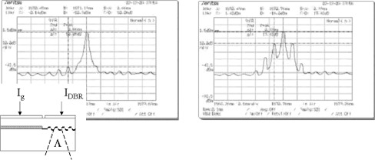
a)
b)
Fig.1.: Measured optical spectra a) at I_{DBR}=168 mA and b) at I_{DBR}= 246 mA.
In the inset a schematic of the SP DBR laser.
[Data from the Radio and Optical communications, RINCE 2003]

The device behaves like an RF optical oscillator. This demonstrates the potential of such a laser for clock recovery at 40 GHz. More information on its performances as clock-recovery function can be seen in [39]-[41].

In this project we proposed to reach further development using self-pulsating lasers as clock recovery function in 160 Gbit/s O3R functions. This challenge will be achieved by using InP-based InAs Q-dots self-pulsating Bragg reflector lasers based active layer. The advantages of the Q-dots are: i) to provide gain at 1.55µm, ii) to suppress the time-jitter thanks to an intrinsic narrow linewidth and iii) an immunity to feedback. The recipe for SP in these devices lays in the same basics than that of the bulk SP DBR laser, i.e. mode beating enhanced by four-wave mixing.
We propose to investigate several configurations for the clock recovery, i.e. at 40Gb/s and 160Gb/s. A Q-dot based active material DBR lasers generates self pulsation from the beating between its modes. At 40 GHz, this is between the closest mode neighbours. However, there is beating between the every second modes, every third and fourth modes. Hence there are electromagnetic overtones of 40GHz generated in this structure. In this proposal we will investigate the potential of 40 GHz DBR lasers for clock recovery at 160 GHz exploiting the overtone of the fundamental 40 GHz electromagnetic wave generated. This solution is really attractive, since the 40 GHz can be used to temporally demultiplexed the 160 Gb/s data stream to 40 Gb/s for bit-error rate measurement as presented in Part 3.
In term of running cost our SP laser will be cheaper as it is based on a standard DBR laser; this implies that the production is well established with low yield. As opposed to the Sartorius’ devices based on dual DFB lasers coupled, requiring an extreme accuracy in order to couple the sub-cavities.

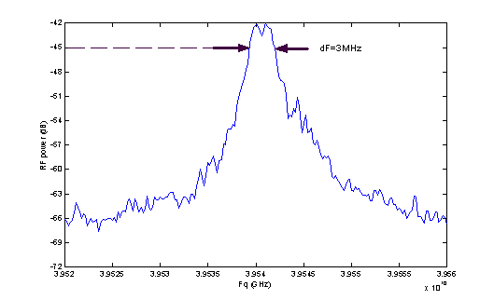

Fig. 2. RF spectrum of self-pulsating frequency.
Resolution bandwidth =Video bandwidth=300kHz.

With a Q-dot active layer, it is expected that SP lasers will achieve higher temperature stability, lower threshold current, a moderate linewidth enhancement factor, and a higher quantum efficiency. The wavelength stability with temperature is also an advantage which can lead to a temperature stability of the self-pulsating frequency. As demonstrated by [40], Q-dot lasers benefit of a reduced high frequency timing-jitter, this should be beneficial to achieve a high quality clock signal.

2. Objectives
The main purpose of this proposal is to explore the potential of a self-pulsating laser as a local oscillator for all-optical clock recovery function in a 40Gb/s to 160Gb/s capacity network.

The objectives are listed as follows:

- Skill development
2 Ph.D. students will be trained during the four years of this project. A post-doctoral researcher will be hired to be in charge of the simulation of the devices, and to mostly co-ordinate the work to be carried out sometimes between the three institutes (DCU, Dublin, Ireland, TNI, Cork, Ireland and III-V Laboratory, Palaiseau, France) and to supervise at the transfer of information from one to the other institute.

- Simulations and design of the Q-dot self-pulsating laser
Simulation tools will be developed to predict: 1) the SP laser design, i.e. Q-dot active layer and DBR section and 2) the SP frequency achieved 3) the quality of the SP signal by the laser simulated and 4) the performance as a clock recovery function.

- SP laser growth and processing
One of the 2 PhD students, called ST1 will spend time in the III-V laboratories to participate to the processing of the Q-dot based devices and to select the relevant devices for the clock recovery. (see letter of support)

- Experimental characterisation of the SP lasers
We will determine the bias current and the temperature range leading to self-pulsation. We will measure the SP signal linewidth and we will extract parameters to refine the simulation tools. Performances as local oscillator of the bulk SP laser will be compared to that of the Q-dot SP laser.

- Clock recovery function
We will investigate experimentally and theoretically the performance the SP laser for an all-optical clock function. Using a 40 Gb/s RZ pseudo random binary sequence (PRBS) transmission and reception scheme, the laser performance will be assessed in terms of both, the synchronization time dependence on the number of “0”symbols in the sequence and on the polarisation orientation of the launched signal. These results achieved will be then compared between the bulk and Q-dot SP laser. The test will be mostly carried out in TNI by student ST2. The timing-jitter, the cut-off frequency in the jitter function, and the extinction ratio of the SP signal are some of the measurement dealt with for the assessment of the clock recovery function..

- O3R regeneration
Our schemes will exploit the cross-phase modulation in the SOA [42,43]. Using a SOA-based interferometer we will re-amplify, re-time, and re-shape an incoming 40 Gb/s data signal and then a 160 Gbit/s O3R function and a demultiplexing at 40 Gbit/s. The performance of this scheme will be mainly determined by the quality of the clock signal, its extinction ratio and its phase noise. The bit-error-rate, tha gain of the O3R function will be measured. These measurements will be carried out in TNI.

- Irish economical development
The knowledge of the device production, characterisation and exploitation of SP lasers will be gained during this project. This knowledge can be transferred to indigenous industry interested in the production of this component (see letter of support).

3. Methodology

- Simulations of SP laser
There are four simulation tools to be developed in this project. The key simulation deals with the gain material provided by the Q-dots based active layer. This simulation solves a system of rate equation describing the time dependence of the carrier populations of the ground sate, excited state and wet layer and for the photon population of each mode involved [44].
The Bragg reflector simulation will determine the number of modes lasing in the cavity. This model will be based on the device’s geometry. It is based on the counter and co-propagation wave. Their propagation is driven by the couple wave equations. From the general equation it is possible to calculate the value of the complex reflection coefficient of the Bragg section [45].
The simulations will be based on the rate equation of the carrier and the complex electric field of a multimode laser. They will include FWM effects, since these are relevant in the process of passive-mode-locking. As demonstrated in some past experiments [46], the self-pulsation in this type of laser cannot be only understood in term of longitudinal mode beating. The self-pulsation results from the correlation of the phase mode due to intra-cavity four-wave mixing. Our models assume that the carrier density modulation is the only non-linear effects generating FWM in the component, even though the free spectral range between the modes is either 40 or 160 GHz. This assumption is based on a previous work carried out by Gray et al. on carrier modulation in a multimode bulk material laser [47]. The formalism used to introduce the FMW in the set of rate equations has been previously developed by Agrawal [48]. For simplicity, our model will be confined to the adiabatic approximation. We suppose that the fluctuation of the phase and the amplitude of each mode are exclusively generated by the spontaneous emission coupled to the modes, selected by the Bragg reflector simulation. To take into account of these fluctuations we introduce Langevin source terms for the carrier population and the electric field of each mode. This set of equations expresses the time dependence of the carrier number and the photon number of each mode. A stability analysis will be performed from the steady state regime, where the time variation is set to zero. From this study we will be able to relate the spectral interval between the first mode and the last mode to the half-locking bandwidth. This expression will be derived from a classical approach given by Adler’s equation. This will link some input parameters, such as the gain, the carrier lifetime, the self-pulsation frequency, the linewidth enhancement factor and the amplitude of each mode to the half-locking bandwidth. We will be able to determine the locking conditions. These are linked to the injection rate terms, and hence related to the spectral distribution of the modes. From the simulation tool developed, we should be able to study the interplay between the longitudinal modes spectrum and the linewidth of the SP signal. When we numerically integrate these equations in the time domain, we will be able to calculate the timing jitter of the power fluctuation, the extinction signal of the power output, and to analyse the impact of the gain material on this metric. The same simulation will be used to study the mechanism of clock extraction. In the time variation of carrier density, an extract component for the injected data signal will be added. We will be able to study the impact of the random sequence on the synchronisation time, to look a power dependence of the injected signal, or the influence of the gain.
Furthermore, we will study the set of time variation differential equations in the frequency domain. Around the steady state determined above, we will firstly perform a small signal analysis up to the first order perturbation of the amplitude and phase of each mode and of the carrier population. We will study in the frequency domain these expressions, and then we will be able to express the electric field and carrier density fluctuation as a function of the Langevin source terms. Knowing the spectral density of the Langevin force, we are able to calculate the spectral density for each individual phase and amplitude fluctuation of each mode. These results will allow us to compare the frequency noise spectrum of the correlated phase in the self-pulsating laser to the uncorrelated phase. From this result we can determine the self-pulsation achieved and the spectrum of the self-pulsating signal.
This simulation toll will benefit from the experimental characterisation in order to refine the bulk and Q-dot SP DBR laser performances.

- Characterization and demonstration of the self-pulsating laser
Experimentally, we will characterize the self-pulsation using the set-up shown in Fig.3. In this experiment the spectral linewidth of the SP frequency will be compared to the sum of each individual linewidth of the optical modes. The spectral linewidth of the SP frequency is to be smaller than the sum of the linewidths of the optical mode; otherwise, the observed self-pulsation is the heterodyne signal of the modes at the level of the photodiode [46], in which case, there is no self-pulsation, only a beating of CW longitudinal modes. The SP characterisation will be performed using the Frequency resolved optical gate (FROG) available in DCU. The FROG will be able to detect modulation at 40-GHz and 160-GHz. We will examine the tunability the SP DBR lasers with current and temperature.

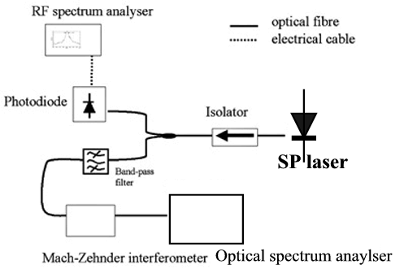
Fig. 3: Experimental characterisation of the SP.

- Clock recovery function
Fig.4 shows a clock extraction experimental set-up. The 40 Gb/s and then ultimately the 160Gb/s RZ data generated are injected at the input 1 in order to synchronize SP DBR laser placed at the output 2. The data signal generated is introduced at the input 2 and exits at the output 3, passing through a band-pass filter in order to suppress the data reflected at the facet of the device. We observe on the spectrum analyzer the linewidth of the carrier at the clock frequency. When the laser is synchronized its linewidth is reduced to that of the clock signal. We can then observe on the sampling scope the signal in the time domain. This experiment will allow us to determine the working condition in order to achieve the clock recovery function. Using the 40 GHz PRBS optical transmission, we will be able to perform a complete assessment of the device and to define experimental condition established. The 160Gb/s will be achieve by time multiplexing the 40GHz signal. For the BERT analysis the signal will have to be demultiplexed to 40 GHz. This is easily done by picking the 40 GHz subharmonic as demonstrated by Shirane et al [49].

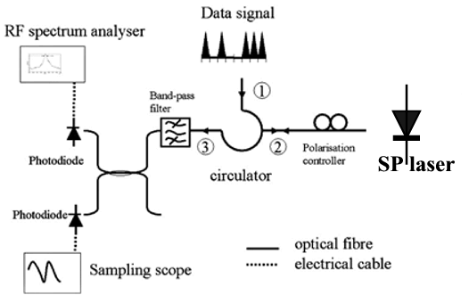
Fig.4: Set-up for clock recovery.

Using this test bed, the performances that we would like to reach are:
- An extinction ratio of the clock signal of at least 13dB,
- An amplitude variation of less than 10%,
- A tunability of 4 nm, corresponding to at least 5 channels according to the international transmission union (ITU) criteria for WDM transmission at 40GHz,
- A sensitivity to polarization of less than 1 dB and
- A temporal jitter of less than 1ps for 40Gb/s and less than 0.25ps for 160 Gb/s.
These performances are required for any system applications. In order to reduce the patterning effect as required to achieve (ii) we will use a combination of passive filters at the input and output of the SP DBR laser under test. These filters are not shown on Fig. 4. The input filter suppresses the continuous spectral components of the PRBS signal and the output filter filters out the transmitted input signal. The ITU-T G825 (March 2000) and ITU-T G.8251 (Nov. 2001) deal with clock recovery at 10 Gbit/s; we have extrapolated this jitter value to 1 ps (.25ps) for 40-GHz (160-GHz) applications.

- O2R function
The performance of an all-optical re-amplification, re-shaping function will be based on an SOA array embedded in a Mach-Zehnder interferometer (MZI) at 40 Gb/s and at 160 Gb/s capacities. The MZI is depicted in Fig.5. The signal to be O2R regenerated is coupled to a MZI where is evenly divided by the two arms of the interferometer. The MZI is configured in such away that with a ‘1’ signal pulse power, the signals recombined constructively and with a’0’, the signal recombined destructively. The OSNR, extinction ratio and the timing jitter of the output signal are measured as a function of the OSNR of the signal injected.

- O3R function
Fig. 5 shows the proposed experimental set-up for the O3R function using a MZI. The pseudo random RZ data sequence is at a bit rate of 40 Gb/s or is optically multiplexed to achieve a 160 Gb/s bit rate. One part is addressed to the SP laser in order to retrieve the clock signal. The other part of the signal is split and then introduced in Port 1 and Port 3 of the interferometer. Port 1 is delayed with respect to Port 3 in order to overcome the limitation induced by a long carrier lifetime in the SOA [42]. With such a scheme, a phase change of π can be achieved in 125-fs switching window [43]. The clock signal is injected in Port 2. The input power at each port and the SOAs are set to obtain a modulation index of π between the power levels of the “1” and “0” symbols. The band-pass filter filters out the clock signal from the output signal of the MZI. The 3R function can be then evaluated by an error detector. At 40 Gb/s the retrieved clock signal from the SP laser can be used as clock input for the error detector. Data out will be compared to the original data sequence produced by the pseudo-random detector.
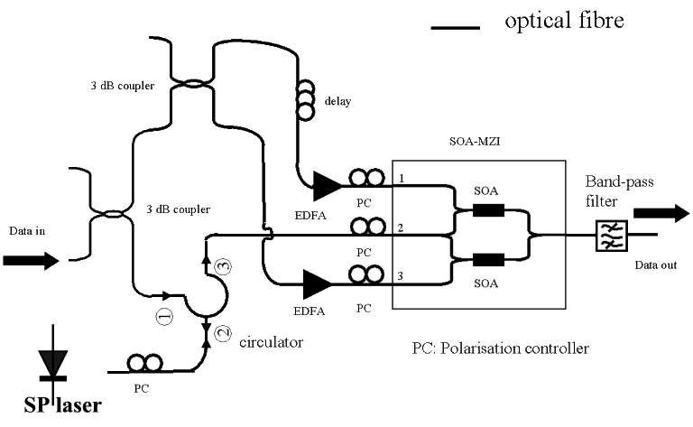
Fig.5: Set-up of 3R regeneration based on Mach-Zehnder all-optical switch

At 160 Gb/s the output signal will be sent into a demultiplexing scheme showed in Fig. 6. The “3R-ed” data sequence at 160 GB/s is launched into a 40 GHz SP DBR laser. This device gets synchronized on the 40 GHz subharmonic component of the data signal. The 40 GHz clock signal is launched with the 160 Gb/s data signal in a semiconductor optical amplifier (SOA), under non-linear operation. The four-wave-mixing is used to perform an all-optical AND logical function. The data signal at λ_{ds} and the clock signal at λ_{sp} generates new optical components at the SOA output. If there is no signal or only one signal at either of these wavelengths, the four-wave mixing will not generate new optical components. The main advantages of this set-up are the simplicity of the display all lasers are DC biased, the transparency of four-wave mixing to the bit-rate [50]. Among the spectral component at the output only one of them will pass through the band-pass filter 2. The data will be converted from an optical signal to an electrical signal and then compared to the original data sequence produced before the optical multiplexing. The 40 GHz clock signal retrieved by the SP laser will be used as input for the error-detector.
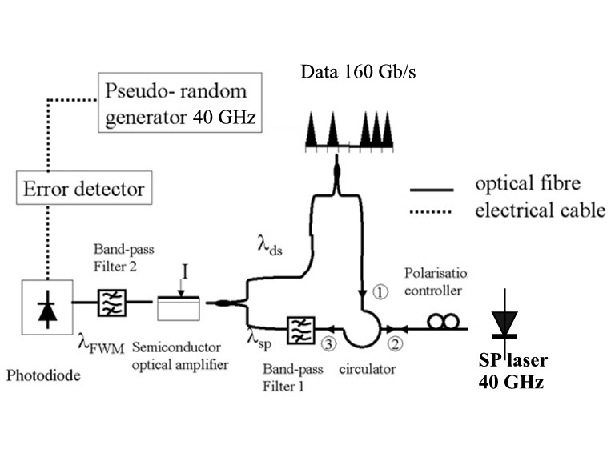
Fig.6: Optical time demultiplexing from 160 GHz to 40 GHz

4. Work plan
The aims of this project are to understand the mechanism of the self-pulsation in Q-dot self-pulsating DBR laser and to assess the performance of this type of component as a clock recovery system in an all-optical 3R regenerator system of 40 and 160 Gb/s capacity. The project is divided into four work-packages as depicted in Gantt chart attached.

Work-package 1 will deal with the project management. This is scheduled for the full duration of the project. A kick-off meeting will be organized at the beginning of this project (D1.1). A report will be produced every year to monitor the progress on the research proposal (from D1.2 to D1.4). The final report will be written at the end of project, this is deliverables D1.5. Two Ph.D. students will be trained during this project. Their graduations are scheduled in November 2010 (D1.6&D1.7).

Work-package 2 deals with the understanding of O3R functions. It is scheduled from the beginning of Year 1 to the end of Year 2. There are two parts in this workpackage. Part 1 is concerned with experimental characterisations of the bulk 40 GHz DBR self-pulsating laser. This will be carried out in DCU from the beginning of Year 1 to the end of the Quarter 1 of Year 2. We will investigate the position of the modes with respect to the material gain peak, the tunability and the linewidth of the self-pulsation, the interplay between the optical modes (i.e. number of longitudinal modes) and the linewidth of the SP signal. A set of experimental results will be selected (Milestone 2.1). They will allow the determination of useful parameters such as linewidth enhancement factor for the determination of the potential of this device for clock recovery (Deliverables 2.2 and 2.3). These parameters will validate the theoretical model based on rate equations including FWM (Task Initial modelling in Work-package 3).
In parallel, the SOA-MZI will be characterised experimentally and theoretically from the beginning of Quarter 1 of Year 1 to the end of Year 2, see Task SOA-MZI characterization. The transfer function of the SOA-MZI will be studied first. Then its potential for signal regeneration will be looked at with measurements on effective gain and Q-factor. From these results the cascadability of the device will be measured and its performances compared with the EDFA will be drawn. This task will be carried out in DCU at 10 Gbit/s and from the knowledge gained, this will be performed in TNI using their 40Gb/s PRBS and error deterctor. The characterisation at 40 Gb/s is scheduled for a duration 15 working days. At the end of Work-package 2, a report on the experimental measurement on the SOA-MZI will be written this is Deliverable 2.4.

The content of Work-package 3 is carried out from Quarter 1 of Year 1 to almost the end of Quarter 4 of Year 3. From the experimental results of Work-package 2, we will have information on the interplay between the number of modes and the strength of the RF signal. The computational tools deal with the simulation of bulk material laser and the reflectivity of the Bragg mirror. It will analyse the dynamic of the modes in the cavity, as described in Part 3. This is the initial modelling. It is completed with the experimental study carried out in Workpackage 2. From the parameter extraction data, it will become more accurate and will be able to compare the simulated enhancement of the linewidth of the SP signal and the extinction ratio to experimental values. From this initial simulation, we will work on a model for Q-dot gain material. Then this model will be integrated in our multi-mode rate equation. Deliverable D3.1 is the completion of the Q-dot SP DBR laser simulation. This tool will be useful to design devices. At least 2 designs will be submitted to fabrication one for self-pulsation at 40 GHz and the second one at 160 GHz, Deliverable 3.1 &3.2. Around mid- Year 3, Student 1 will contribute to the fabrication and testing of devices. He will spend 100 days in Alcatel-Thales III-V. Some first test and measurement on the devices will be performed first in the III-V laboratory. This first selection will be determined the lasing devices, their emission wavelength versus position on the wafer. At the end of this workpackage we will have a selection of devices self-pulsating at 40 or 160 GHz. This is Milestone M3.5.

The work proposed Work-package 4 is performed from Quarter 1 of Year 3 to the end of the Quarter 1 of Year 4. It deals with the development of an optical 3R function at 40 Gb/s. It is proposed to look at modification of XOR devices, to implement a full Pi phase shift in the differential time configuration and to test an interferometer structure (see Fig.5). The first tasks of this workpackage will be carried out in DCU with a 8-ps pulse width multiplexed signal. The data sequence will correspond to the ideal transmission of only pulses. In our limited set-up we will gain some information on the experimental working condition of the O3R. For the last task, gain and Q factor measurements, the post-doctoral researcher will go to TNI’s to benefit of the 40Gb/s test bed. The results achieved will be compared to those of the Workpackage 2 and will be compiled in a report (Deliverable 4.1).

Work-package 5 is scheduled from the beginning of Quarter 2 of Year 4 to the end of Quarter 4 of Year 4. In a first attend of demonstration of 160 Gb/s O3R function 2ps pulses will be multiplexed. Initial we will study the performance of the Q-dot SP DBR laser for clock recovery and then we will study the possibility to synchronise the Q-dot SP laser to a sub-harmonic of the input signal at 160Gb/s to process the signal but also to temporally demultiplex it. The pseudo-random measurement at 160 Gb/s will be carried in TNI. The impact of the sequence pattern, the Q-factor and gain measurement will be measured. The transmission measurement will be then carried out, with a special care for the impact of the sequence pattern on the timing-jitter. The cascability of the device will be studied too. At the end of this workpackage the working condition of an optimised configuration will be achieved. We will report on the performance of the SP DBR laser as a clock recovery for an O3R function at 160Gb/s. This is deliverable 5.1.

In Work-package 6, a closer interaction between the III-V laboratory and our laboratory will take place. The aim of this work-package will be to look at the device specification and tolerance for further development towards commercialisation of the Q-dot SP DBR laser. This workpackage will be scheduled from Quarter 1 of Year 3 to Quarter 4 of Year 4. We will determine the specification for the successful 160GHz laser (M3.2&M3.3) The results concerning the SOA-MZI (D2.3) will be used in this workpackage. We will assess the process tolerance. During this time, the performances achieved will be compared to the simulation predictions, in order to improve our computational tool. From this last simulation test, devices will be generated which then will be tested.

Milestones and deliverables: Check list

Workpackage’s title | Milestones or deliverables
Management | D1.1: Kick-off meeeting  D1.2-D1.4: Progress reports  D1.5: Final report  D1.6&D1.7 PhD graduations
Understand O3R | M2.1: Agreed set of measurements  D2.2: Characterization of SP DBR laser  D2.3: Parameter extraction  D2.4: Report on SOA-MZI Characterization
Development 160GHz Q-dot SP laser | D3.1.:Simulation of q-dot based SPSFP laser  D3.2 & D3.3.: Delivery of 40 GHz and 160 GHz laser design.  D3.4: Delivery of devices  M3.5:Selection of 40 GHz and 160 GHz devices
Develop 40Gb/s O3R | D4.1: Report on O3R function
Demonstration of 160 Gb/s O3R | D5.1: Demonstration of O3R
Design for manufacture | M6.1: Laser processing tolerances  D6.2: Simulation tool

5. Expected outputs
The technical outputs of the project are listed as follows:
- Develop complete characterization of 40 and 160 GHz self-pulsating lasers.
- Construction of a clock recovery test bed.
- Assessment of self-pulsating laser for all-optical clock extraction.
- Assessment of self-pulsating laser for all-optical 3R generation
- Computation models to design self-pulsating laser.
- Design and development of a novel self-pulsating stabilized Fabry-Perot laser.
- Development of knowledge to patents in device design and/or network applications. IPR will be exploited in consultation with DCU &TNI’s innovation and Business Relations Office.
- Presentation of the results in international conferences and refereed journals.
- Create a Centre of Excellence for optical telecommunications with unique expertise in Ireland.
- Raise profile of telecom component and system research in Ireland.

The human resource outputs are:
- Training of 2 post-graduate students in DCU.
- High level training of 1 post-graduate researcher.
- Develop further links with international institutes.
- Technology which can be exploited by indigenous Irish industry
- Strengthen involvement in national and European research funding.
- Attract international researchers to DCU or UCC for sabbatical periods.
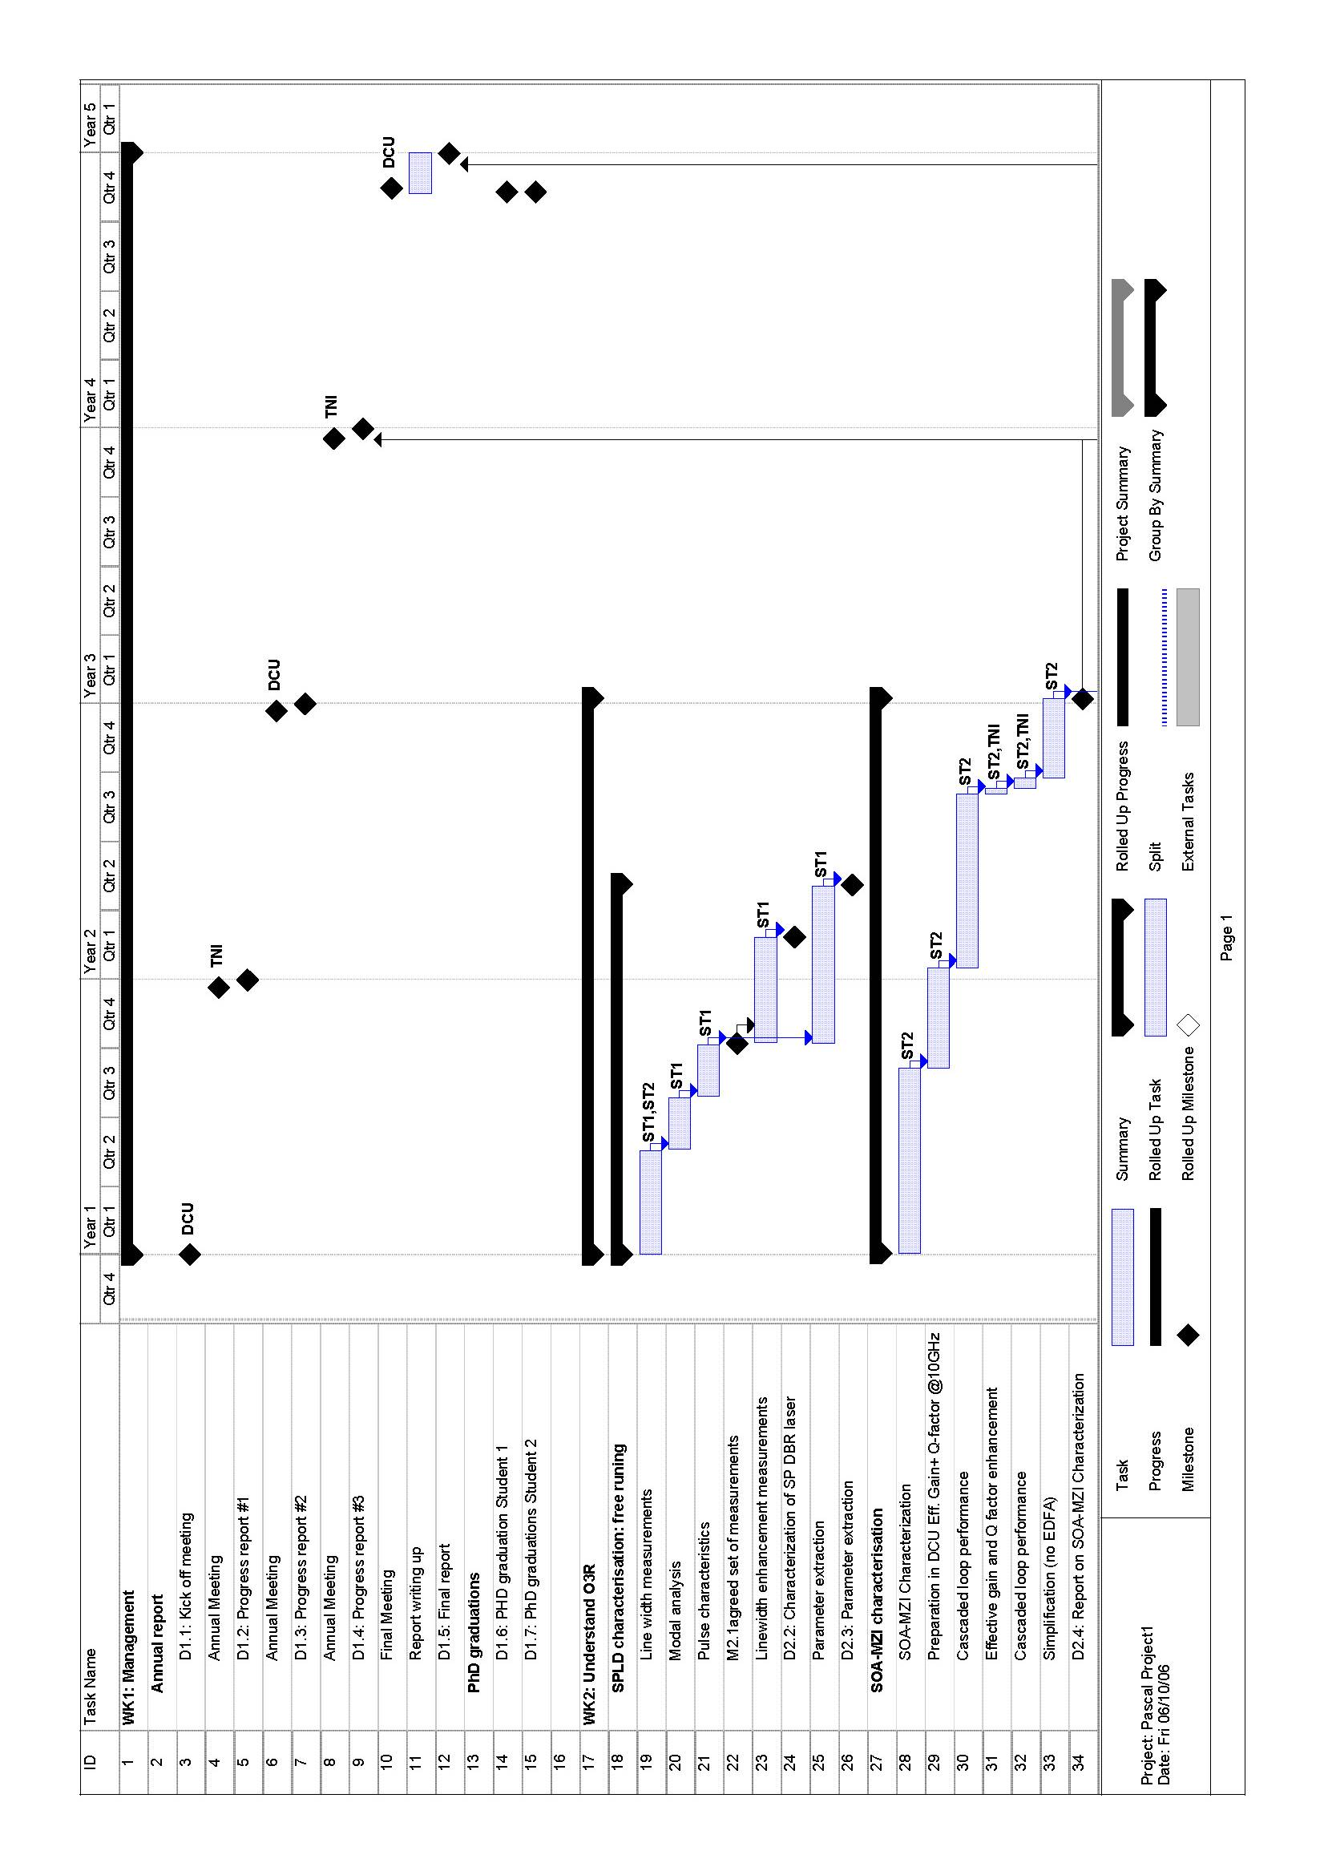
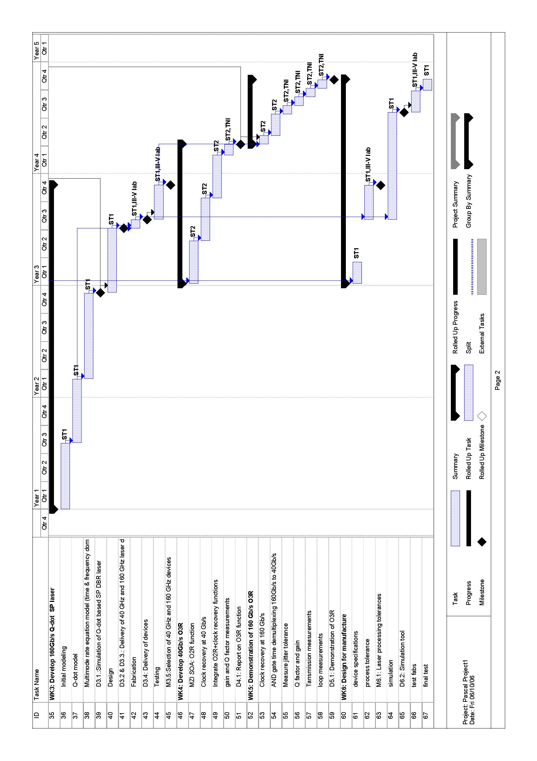

6 References
[1] www.telegeography.com
[2] www.kmipennet.com
[3]http://europa.eu.int/information_society/eeurope/2002/news_library/documents/eeurope2005/eeurope2005_en.pdf
[4] Sean Michael Kerner,”On the road to 100GbiEthernet”, http://www.internetnews.com/infra/article.php/3583631, February 2006.
[5] M. J. O’Mahony, “The application of optical packet switching in future communication networks,” IEEE Communication Magazine, 2001, vol.19, pp.128-135.
[6] A. Jourdan “The perspective of optical packet switching in IP dominant backbone and metropolitan networks,” IEEE Communication Magazine, 2001, vol. 39, pp.136-141.
[7] B. Lavigne, P. Guerber, P. Brindel, E. Balmefrezol, and B. Dagens, “Cascade of 100 optical 3R regenerators at 40 Gbit/s based on all-active Mach-Zehnder interferometer,” European Conference on Optical Communication, 2001, Paper We.F.2.6, pp.290-291.
[8] J. Renaudier, B. Lavigne, P. Gallion, and G.-H. Duan, “Study of phase-noise properties and timing jitter of 40-GHz all-optical clock recovery using self-pulsating semiconductor lasers,” Journal of Lightwave technology, 2006, vol. 24, pp 3734-3737.
[9] T. Wang, Z. Li, C. Lou, Yue Wu, and Y. Gao, “Comb-like Filter preprocessing to reduce the pattern effect in the clock recovery based on SOA,” IEEE Photonic Technology Letters, 2002, vol. 6, pp. 855-857.
[10] C-L Lu, T. K. Fong, R T. Hofmeister, P. Poggiolini, L. G. Kazosky, “CORD-A WDM optical network: Design and experiment of fast data synchronization by pilot-tone transport,” IEEE Photonic Technology Letters, 1996, vol. 8, pp. 1070-1072.
[11] E.S.Awad, P.S.Cho, C. Richardson, N.Moulton, and J.Goldhar, ” Optical 3R regeneration using a single EAM for all-optical timing extraction with simultaneous reshaping and wavelength conversion,” IEEE Photonic Technology Letters, 2002, vol. 14, pp. 1378-1380.
[12] I.D.Phillips, A.Gloag, D.G.Moodie, N.J.Doran, I.Bennion, A.D.Ellis, “Drop and insert multiplexing with simultaneous clock recovery using an electroabsorption modulator,” IEEE Photonic Technology Letters, 1998,vol. 10, pp. 291-293.
[13] X. S. Yao and L. Maleki, ”Optoelectronic oscillator for photonic system”, IEEE Journal of Quantum Electronics, 1996, vol.32, pp 1141-1149.
[14] I. Kang and M.Yan, ”Simple set-up for simultaneous clock recovery and ultra short sampling pulse generation,” Electronics Lettres, 2002, vol. 38, pp 1199-1201.
[15] L.J. Wang, H.X.Shi, J.T.Lin, K.J.Guan, P.Ye, ” Clock and frame synchronization recovery based on a terahertz optical asymmetric demultiplexer,” IEEE Photonic Technology Letters, 1998, vol. 10, pp. 881-883.
[16] A. Bilenca, D. Dahan, J. Lasri, G. Eisenstein, and D. Ritter, “High bit rate clock recovery of NRZ data by all optical processing in a semiconductor optical amplifier and direct optical injection locking of a self-oscillating phototransistor,” IEEE Photonic Technology Letters, 2002, vol. 14, pp. 399-401.
[17] D.T.K. Tong, B. Mikkelsen, G. Raybon, T.N.Nielsen, K.F.Dreyer, and J.E.Johnson,” Optoelectronic phase-locked loop with balanced photodetection for clock recovery in high-speed optical time-division-multiplexed systems,” IEEE Photonic Technology Letters, 2000, vol. 12, pp. 1064-1066.
[18] F.Centurelli, M.Magliocco,A. Pallotta, P.Tommasino, and A.Trifiletti” A compact 3R-receiver module for short-haul SDH STM-16 systems,” Journal of Lightwave Technology, 2001, vol. 19, pp. 1307-1315.
[19] L. Wang, Y. Su, A. Agarwal, P. Kumar, “Polarization insensitive widely tunable all-optical clock recovery based on AM mode-locking of a fibre ring laser,” IEEE Photonics Technology Letters, 2000, vol.12, pp.211-213.
[20] B.K. Mathason and P.J. Delfyett, “Pulsed injection locking dynamics of passively mode-locked external-cavity semiconductor laser systems for all-optical clock recovery,” Journal of Lightwave Technology, 2000, vol. 18, pp. 1111-1120.
[21] K. Vlachos, G. Theophilopoulos, A. Hatziefremidis, and H. Avramopoulos, “30 Gbit/s all-optical clock recovery circuit,” IEEE Photonic Technology Letters, 2000, vol. 12, pp. 705-707.
[22] S. Bigo, O. Leclerc, and E. Desurvire, “All-optical fiber signal processing and regeneration for soliton communications,” IEEE Journal of Selected Topics in Quantum Electronics, 1997, vol. 3, pp. 1208-1223.
[23] L.E. Adams, E.S. Kintzer, and J.G. Fujimoto, “Performance and scalability of an all-optical clock recovery figure eight laser,” IEEE Photonics Technology Letters, 1996, vol.8, pp.55-57.
[24] K.L. Hall, D.T. Moriarty, H. Hakimi, F. Hakimi, B.S. Robinson and K.A. Rauschenbach, “An ultrafast variable optical delay technique,” IEEE Photonics Technology Letters, 2000, vol.12, pp.208-210.
[25] K.L. Deng, I. Glesk, K.I. Kang and P.R. Prucnal, “Unbalanced TOAD for optical data and clock separation in self-clocked transparent OTDM networks,” IEEE Photonics Technology Letters, 1997, vol.9, pp.830-832.
[26] M. Jinno and T. Matsumoto,“ All-optical timing extraction using a 1.5um self-pulsating multielectrode DFB LD,” Electronics Letters, vol.24, pp.1426-1427, 1988.
[27] M. Ueno and R. Lang,“ Conditions for self-sustained pulsation and bistability in semiconductor lasers,” J. Appl. Phys., 1985, vol. 58, pp.1689–1692.
[28] P.E. Barnsley, H.J. Wickes, G.E.Wickens, and D.M. Spirit,“ All-optical clock recovery from 5Gb/s RZ data using a self-pulsating 1.56μm laser diode,” IEEE Photonics Technology Letters, 1991,vol.3 ,pp. 942–945.
[29] B. Sartorius, M. Mohrle, and U. Feiste,“12–64 GHz continuous frequency tuning in self-pulsating1.5um multi-quantum-well DFB lasers,” IEEE J. Select. Topics Quantum Electron., 1995, vol.1, pp.535–538.
[30] G.-H. Duan and P.Landais, “Self-pulsation in multielectrode distributed feedback lasers,” IEEE Photonics Technology Letters, 1995, vol.7, pp.278–280.
[31] B.Sartorius, M.Mohrle, S.Reichenbacher, H.Preier, H.-J. Wunsche, and U.Bandelow, “Dispersive self- Q-switching in self-pulsating DFB lasers,” IEEE J. Quantum Electron., 1997, vol.33, pp.211–218.
[32] G. Pham and G.H. Duan, “Self-pulsation in two-section DFB semiconductor lasers and its sysnchronization to an external signal,” IEEE J. Quantum Electron., 1998, vol.34, pp.1000–1008.
[33] D.D. Marcenac and J.E. Carroll, “Distinction between multimoded and singlemoded self-pulsations in DFB lasers,” Electron. Lett., 1994, vol.30, pp. 1137–1138.
[34] P.Phelan, D.McDonald, A.Egan, J.Hegarty, R.O’Dowd, G.Farrell, and S.Lindgren, “Comparison of self-pulsation in multisection lasers with distributed feedback and intra cavity saturable absorbers,” Proc. Inst. Elect. Eng., 1994, vol.141, pp.114–118.
[35] H.Wenzel, U.Bandelow, H.-J.Wunsche, and J.Rehberg, “Mechanisms of fast self pulsations in two-section DFB lasers,” IEEE J. Quantum Electron., 1996,vol.32, pp.69–78.
[36] K. Sato, “100 GHz optical pulse generation using Fabry-Perot laser under continuous wave operation,” Electronics Letters, 2001, vol. 37, pp 763-764.
[37] Y. Nomura, S. Ochi, N. Tomita, K. Akiyama and T. Isu, “Mode locking in Fabry-Perot semiconductor lasers,” Physical Review A, 2002, vol. 65, 043807, pp 1-11.
[38] P. Landais, J. Renaudier and G.H. Duan, “Analysis of self-pulsation in distributed Bragg reflector laser based on four-wave mixing”, Society of photo-Optical Instrumentation Engineering, Physics and Simulation of Optoelectronic Devices XII, 2004, vol. 5349, pp 263-270.
[39] P. Landais,” Analysis of Self-Pulsation in Distributed Bragg Reflector Lasers based on Four-Wave Mixing”, 2004, COST meeting Athens.
[40] J. Renaudier, B. Lavigne, M. Jourdran , P. Gallion, F. Lelarge, B. Dagens, A. Accard, O. Legouezigou, G.-H. Duan, “First demonstration of all-optical clock recovery at 40 GHz with standard-compliant jitter characteristics based on a quantum-dots self-pulsating semiconductor laser”, ECOC, 2005, vol.6, pp:31 - 32
[41] B. Lavigne, J. Renaudier, F. Lelarge, O. Legouezigou, H. Gariah, G.-H. Duan, S. Bigo, “OSNR and jitter tolerant all-optical clock recovery at 40 Gbit/s using a quantum-dots based self-pulsating laser”, 2006, OFC, pp OthG5.
[42] S. Nakamura, Y.Ueno, K. Tajima, J. Sasaki, T. Sugimoto, T. Kato, T. Shimoda, M. Itoh, H. Hatakeyma, T. Tamanuki, and T. Sasaki, “Demultiplexing of 168 Gbit/s data pulses with a hybrid-integrated symmetric Mach-Zehnder all-optical switch,” IEEE Photonics. Technology Letters, 2000,vol.12 , pp. 425–427.
[43] R.P. Schreieck, M.H. Kwkernaak, H. Jaeckel, and H. Melchior, “All-optical switching at multi-100-Gb/s data rates with Mach-Zehnder interferometer switches,” IEEE J. Quantum Electron., 2002,vol.38, pp.1053–1061.
[44]T. W. Berg, S. Bischoff, I. Mangnusdottir, and J. Mork, “Ultrafast gain recovery and modulation limitations in self-assembled quantum-dot devices”, IEEE Photonics Technology letters, 2001, vol. 13, pp. 541-543.
[45] Y. Suematsu, S. Arai, and K. Kishino, “Dynamic single mode semiconductor lasers with a Bragg reflector”, Journal of Lightwave Technology, 1983, vol. 1, pp. 161-176.
[46] J. Renaudier , G.-H. Duan, P. Landais,P. Gallion, “Phase Correlation and Linewidth Reduction of 40 GHz Self-Pulsation in Distributed Bragg Reflector Semiconductor Lasers”, accepted for publication in IEEE J. Quantum Electron.
[47] G. R. Gray and G. P. Agrawal, “Importance of Self-Induced Carrier-Density Modulation in Semiconductor Lasers,” 1992, IEEE Photon. Techno. Letters, vol. 4, pp. 1216-1219.
[48] G.P. Agrawal and I.M.I. Habbab, ”Effect of four-wave mixing on multichannel amplification in semiconductor laser amplifiers,” IEEE J. Quantum Electron., 1990,vol.26, pp.501–505.
[49] M.Shirane,Y. Hashimoto, H. Kurita, H. Yamada, and H. Yokoyama, “Optical sampling measurement with all-optical clock recovery using mode-locked diode lasers”, Conference and Exhibit of Optical Fiber Communication, 2001, vol.1, pp. MG2-1 MG2-3.
[50] S.L Jansen, M. Heid, S. Spalter, F. Meissner, C.-J. Schopflin, D. Khoe, H. de Waardt, “Demultiplexing 160 Gbit/s OTDM signal to 40 Gbit/s by FWM in SOA”, Electronics Letters, 2002, vol.38,pp 978 - 980.

